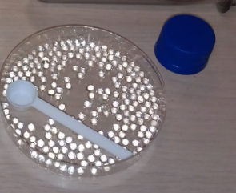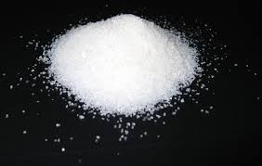

Highlighting the Importance of Hydrogels
Hydrogels are chemical compounds that can absorb and retain extremely large amounts of water relative to their own mass. Hydrogels are part of a family of compounds called Superabsorbent Polymers (SAPs) that are unique in their ability to absorb tremendous amounts of certain liquids. Some hydrogels can absorb over 300 times their own weight in pure water and, in doing so, they can expand up to 60 times their original volume. Some hydrogels absorb water almost instantly and some do it gradually over several hours. Hydrogels will also absorb water from any solution that contains water as the primary ingredient. Thus, they will also work with water-based mixtures such as soft-drinks, tap water, or bodily fluids. These compounds also possess a degree of flexibility very similar to natural tissue, due to their significant water content.
It’s not surprising that hydrogels are extremely useful compounds since there are lots of situations where excess water is an unwanted and often expensive problem. Plumbers use them to soak up standing pools of water when the water pipes break in a house. Emergency rooms use them to bind up the liquid blood from injured patients that drips on tables and floors. Hydrogels are also used by gardeners as water retention agents and as artificial snow for motion picture and stage production. Its most common use, however, is in disposable diapers. In this case, the hydrogel used is a white powder called sodium polyacrylate. This white powder is engineered into the fabric of the diaper. When babies urinate, the sodium polyacrylate absorbs the urine into the diaper and away from their skin. This helps to keep their backsides dry and it even helps to prevent diaper rash.
Hydrogels are made of polymers – long molecules made up of repeating chains of atoms. When these polymer chains are surrounded by water molecules, the chains “unwind” and expose binding sites for water molecules. Water molecules move from outside the hydrogel marble to the inside by diffusion. As water bonds in these sites, a gel is formed. In essence, the molecule is like a spring that unwinds, exposing more sites that can bind with water. But a hydrogel’s ability to absorb water is not infinite – once all the binding spots for water are occupied, it cannot bind any additional water molecules. When the hydrogel marbles are removed from water, the decreased concentration of water outside the hydrogel will cause it to start releasing water from its binding sites. Overtime, the hydrogel marble will shrink to its original size and it can even be used again. One thing for sure, hydrogels are very amazing molecules.

Contributed by:
​Dr. Tom Brown,
GYSTC Director of Statewide Programs
tbrown@kennesaw.edu

