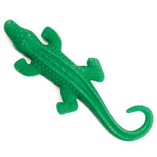
Measuring Our Growing Gator
Our Gator’s Name: ______________________
Our Gator’s Humans: ______________________
One time each day:
Please take the gator out of the water, pat in dry, and:
- Observe your gator closely and describe any changes.
- Measure how much it has grown in length?
- Measure much it has grown in weight (mass)?
- Graph the change in length of the gator over time.
Day # | Observations: | Length of Gator (cm) | Weight of Gator (grams)
O (start)
1
2
3
4
5
6
7
8
9
10

Measuring Our Shrinking Gator
Our Gator’s Name: ______________________
Our Gator’s Humans: ______________________
One time each day:
Please take the gator out of the water, pat in dry, and:
- Observe your gator closely and describe any changes.
- Measure how much it has grown in length?
- Measure how much it has grown in weight (mass)?
- Graph the change in length of the gator over time.
Day # | Observations: | Length of Gator (cm) | Weight of Gator (grams)
O
1
2
3
4
5
6
7
8
9
10

