The Amazing Mystery Powder
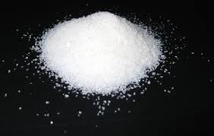
“Waterlock” is a chemical that is normally found in the form of small white crystals that resemble powdered sugar. The scientific name for this chemical is sodium polyacrylate. It was invented by scientists about 40 years ago and it has the amazing ability to absorb hundreds of times its own weight in water. As it absorbs particles of water, it binds them up in gel form so that the water is no longer able to flow freely.
Waterlock is often used in situations where water and other liquids are undesirable. Plumbers use it to soak up standing pools of water when the water pipes break in a house. Emergency rooms use it to bind up the liquid blood from injured patients that drips on tables and floors. Its most common use, however, is in disposable diapers. Waterlock powder is engineered into the fabric of the diaper. When babies urinate, the Waterlock absorbs the urine into the diaper and away from their skin. This helps to keep their backsides dry and it even helps to prevent diaper rash. The interaction between the Waterlock and the urine produces a gel that gives a wet diaper it’s weight and feel.
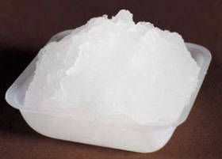
Waterlock is a polymer – a long molecule made up of repeating chains of atoms. When these chains are surrounded by water molecules, each chain “unwinds” and exposes binding sites for the water molecules. As water bonds with the crystal, a gel is formed. While Waterlock’s ability to absorb water amazing, it is not infinite and once all the binding spots for water are occupied, it cannot bind any additional water molecules. The Waterlock is effectively saturated and it’s capacity to absorb water is reached. However, this capacity is still quite incredible and is unlike any natural substance on the planet.
Contributed by:
​Dr. Tom Brown,
GYSTC Director of Statewide Programs
tbrown@kennesaw.edu

