Rocket Power STEM Challenge Student Sheet 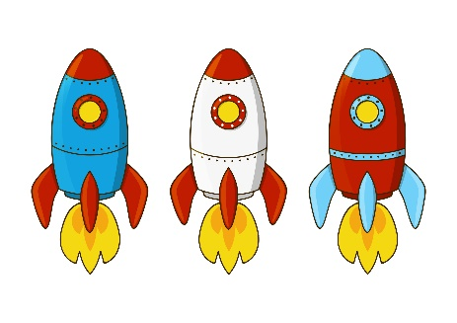
After watching the NASA video, brainstorm questions that you have about the launching of a rocket?

The Challenge:
In this exploration, your job is to construct a model rocket to simulate the launch of a real NASA rocket. Your challenge is to find what combination of fuel (Alka-Seltzer and water) produces the most effective launch. In order to do so, you will be given the following materials:
2 pieces of paper, an index card, scotch tape, a pair of scissors, a film cannister and cap, 2 tablets of Alka-Seltzer. The index card can be used to cut fins for the rocket that helps to stabilize its flight. The paper can be used to build the body of the rocket and the nose cone which helps to reduce air resistance. The cannister should hold your fuel at the bottom of the rocket.
Plan your design and then draw a sketch of your rocket design below. Label each part of your design.

Procedure:
- Obtain the materials listed above.
- Construct your rocket according to your design.
- Determine how much water and how much Alka-Seltzer you want to use.
(ex. ¼ tablet and ½ cannister of water). Use fractions to express your amounts.
- Record on the table below how much of these you will use for the first trial.
- When your group is ready to launch, put the piece of Alka-Seltzer in the lid of the cannister. QUICKLY put the lid on tightly and then set the rocket upright.
- Be patient and wait for it to launch and make sure no one steps into the line of fire. When it launches, measure the time that it stayed in the air. Record your measurements below.
- Repeat this procedure 3 more times using different combinations of Alka Seltzer and water. Try to determine the best combination.

Trial Number | Amount of Alka Seltzer Used | Amount of Water Used | Time Rocket  Traveled (sec)
1

2

3

4

Questions:
- According to your results, what combination of Alka-Seltzer and water produced the most effective shooting rocket?

- Describe how you think the force (push) was produced that caused the rocket to be propelled out of the launcher. Do you think this is an example of a cause-effect relationship?

- Besides the amounts of Alka-Seltzer and water, describe two other factors that you think might have some effect on the flight distance of the rocket.

- What do you think is one thing that your group could do to improve the rocket design and make it go further?

- If time permits, make the improvement on your rocket and launch it again. Did your design change improve the performance of your rocket?

