Some Mobius Strip STEM Connections to Consider
The Mobius strip was discovered in 1858 by a visionary mathematician and astronomer August Mobius. A Mobius strip forms one of the most famous surfaces in mathematics. The surface is an unusual one – a one-sided surface that is non-orientable. Mobius was able to show that these strange one-sided surfaces are actually an integral part of mathematics, magic, science, art, engineering, literature, and music. He was able to make some amazing connections. As such the Mobius strip, has also become a metaphor for change, strangeness, looping, and rejuvenation.
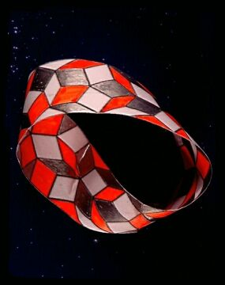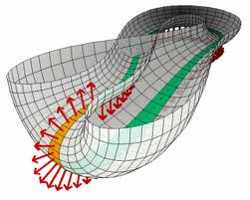
In science, University of Warwick researchers have shown how to tie knots in liquid crystals using a miniature Mobius strip made from silica particles. By tying substances like these in knots, the researchers hope to understand how their intricate configurations and unique properties can be harnessed in the next generation of advanced materials and light detecting devices. Environmental scientists have also chosen the Mobius Strip as the Universal symbol of recycling. As such, it represents the process of transforming waste materials into useful resources. Meanwhile, engineers for the B. F. Goodrich Company have patented a conveyor belt in the form of a Möbius strip which reportedly lasts twice as long as conventional belts.
Finally, the Mobius strip has become important cultural symbol of non-duality. It is used to represent the Unity of all polarities, creating a state of Oneness, joining the whole and the part, the masculine and the feminine, expansion and contraction, and even spirit and matter. The strip demonstrates how everything is One and nothing can be separated from anything else. It is pretty cool to see that a simple twisted strip of paper can be used to help us consider how everything in our world is so cleverly connected.
Can you make your own Mobius Strip to show connections between key science concepts?
Contributed by:
​Dr. Tom Brown,
GYSTC Director of Statewide Programs
tbrown@kennesaw.edu

