The Mystery of the Red Cups
by Dr. Tom Brown

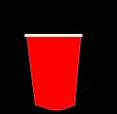

When we came back from lunch today, Mrs. Craig had 3 bright red plastic cups lined up on her table. She told us that we were about to do one of her very favorite science activities. That got all of us excited because Mrs. Craig knew a lot of cool science stuff.

She had us sit up front on the carpet and whispered that we needed to be very careful watchers of the three red cups. I scooted to the side because Jose was in front of me and he wasn’t sitting criss-cross applesauce like he was supposed to. Ms. Craig asked us to take a minute and think about why it was so important for scientists to be careful watchers. Give the kids a minute or so to come up with their own ideas and then have 2-3 of them share with the rest of the class.

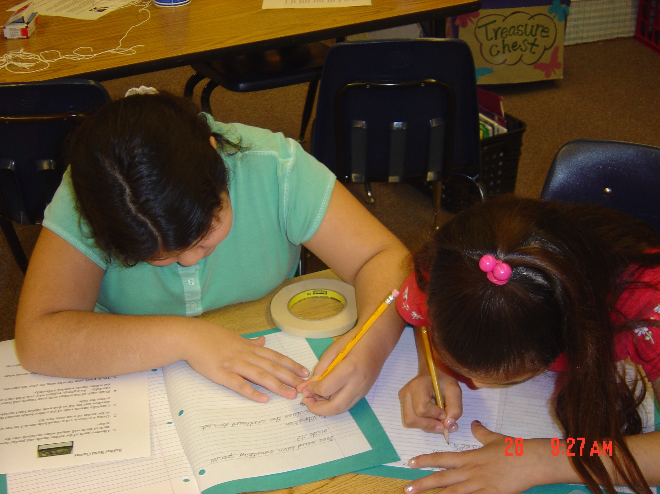

I was surprised at all the good ideas we came up with but I wasn’t really sure about it myself. I thought that scientists were probably pretty careful about everything – including stuff like watching. Mrs. Craig said that when scientists watch something carefully they like to say that they are making observations. She suggested that scientists might use these observations to help them explain the things that happened in our world.

Then, Mrs. Craig told us that she was going to test our ability to be a careful watcher. She was going to pour water into one of the red cups and then shuffle the cups around quick like a bunny. As she showed us that the cups were empty, she told us that our job was to keep track of which of the cups had the water in it. Now I was pretty sure that I could do this since my eye sight was 20-20 and all. Show everyone that the cups are empty (be careful).



Well, she poured some water into the middle cup and then she started to shuffle the cups around and around. I watched real close and made sure not even to blink. When she finally stopped moving them, Mrs. Craig said that, in order to make it fair, she would let each of us vote on the cup that we thought had the water. Shuffle the cups around for a minute or so. Make sure that the middle cup has the water in it when you stop.

First, she pointed to the cup on our left and looked at us to see how many of us had raised our hand. She looked disappointed when not one person raised their hand. And sure enough, when she tipped the cup over (tip the cup over), not even a drip drop fell out. When she pointed to the cup on the right and nobody raised their hand, I was kind of sad because I wanted to be the only one who got it right. Then, (tip the cup over) she flipped it over and it was dry as a bone too. I guess it wasn’t so hard to figure out.



But, once again, she had us vote and after we all voted for the one in the center, she told us to give ourselves a hand and we all clapped eagerly at our unanimous braininess. Then, after it got quiet again, she slowly lifted and quickly flipped over the final cup (lift and flip over the middle cup) and the whole class gasped when nothing, not anything, came out of the cup. I knew that Mrs. Craig was a cool teacher – but now she’s like Harry Potter too.

I really, really wanted to see inside that cup but Ms. Craig made sure that we all stayed sitting down. When she asked us to come up with ideas that could be used to explain what happened to the water, my brain was already aching trying to figure it out. She encouraged us to brainstorm a bunch of ideas without worrying whether they were the best or not. And she made sure that we didn’t say them out loud so that we could all think for ourselves. Give students one or two minutes to brainstorm ideas individually.

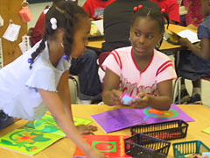

Then she told us to get with a partner and talk about our ideas together because even smart people like doctors talk about and test their thinking. Let students talk with their person next to them for a minute and then take 2-3 minutes to share ideas as a class. I was real surprised with all the good ideas that our class came up with. We came up with these possible explanations for what happened to the water. List the ideas that the class developed. Ms. Craig was real impressed that we came up with so many creative ideas and she said that many of them could actually be used to explain the what happened to the water.

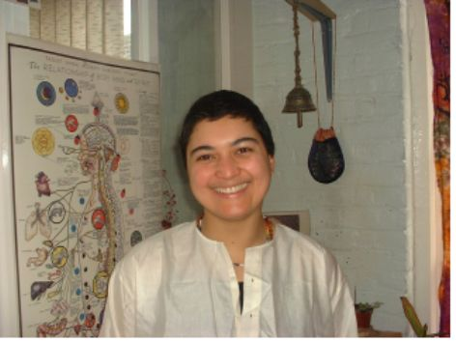

Then Mrs. Craig looked at us with her real excited eyes and she said that she was going to show us one of her very favorite substances in the whole wide world. I wasn’t sure what a substance was but I could hardly wait to see it. Then she dipped her spoon into a plastic bottle and pulled out a half spoonful of a white powder that looked anything but cool. It looked to me like that sugary stuff that my mom puts in her coffee. But Ms. Craig told us that even though it looked boring it was actually very amazing. She said that it could do one thing better than anything else on the whole planet – absorb water. When she said that it could absorb 800 times its own weight in water we ooohed and aahhhed because that seemed almost impossible. She said that if you were a hundred pound chunk of this stuff and jumped into a swimming pool, you would suck up 80,000 pounds of the pool water. That pretty much seemed like a whole pool to me.

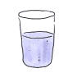
But Ms. Craig never expected us to believe stuff just because someone said so. She liked us to see it for real. So we weren’t surprised when she pulled a clear plastic glass from her desk and said that it was time to experiment. She filled it mostly full of water and lifted up the glass so we could all see it. Then, she poured in the half spoon of white powder and stirred it real quick. (Lift up the cup, pour in the powder and stir quickly) Within a second or two the swirling water stopped and it seemed like it froze right in the cup. Then she flipped the cup over (flip it) and nothing came out and we were so excited that we started to clap (clap). Ms. Craig said that scientists invented this stuff about twenty years ago and they decided to call it Waterlock because that is pretty much what it does.
Then she asked us to think again about what happened to the water in the red cups and a bunch of us figured out there was probably some Waterlock stuff in the bottom. Ms. Craig suggested we check and she turned the one of the cups upside down and patted it on the tabletop. In a few seconds, a chunk of jello-like stuff plopped out that looked to me like a hockey puck. I really wanted to touch the stuff bad but Ms. Craig said it was so good at absorbing water that it could even suck it out of our eyes. That was really cool.

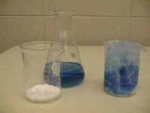

Mrs. Craig then explained that we could invent something like this if we worked hard to understand substances and other chemical stuff. She even said that if we invented some new stuff like this ourselves we could get a patent for it and make lots and lots of money. I wasn’t sure what a patent was but the money part sounded real good.

Then she told us that lots of time people invent stuff but don’t really figure out all the best ways to use it. So she asked us to pretend that we were the scientists who just invented it and she wanted us to brainstorm new ways that Waterlock could be used. This part will be easy. Give students one or two minutes to brainstorm ideas individually and then let students talk with their person next to them for a minute or so. Finally, take 2-3 minutes to share ideas as a class and list them on the board.

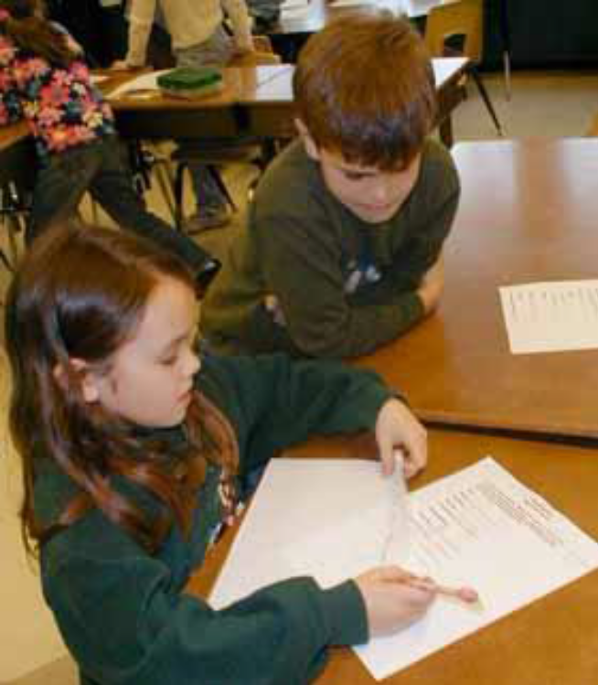

This time, we came up with even more good ideas than before and I had all kinds of possibilities racing through my head. But even though we came up with some great ways for Waterlock to be used, Mrs. Craig said that we still hadn’t figured out who used the very most of it. So she asked us to think of somebody who spilled a lot because they couldn’t help it and before we could answer Will yelled out “babies” without even raising his hand. Mrs. Craig gave Will the eye before she asked the rest of us to figure how all babies spill 5-6 times a day.

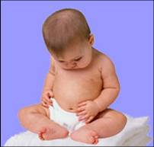

Pretty soon she started patting herself below her waist and asked us to think where babies spill down here and then Maria raised her hand and proudly announced that it was in their diapers. Well she was right of course and Ms. Craig said that, these days, every diaper in America has Waterlock in it and since potty is mostly water, it gels up in a diaper just like the water does in a glass. This keeps the potty from leaking through the diaper to the babies pants and maybe even onto mom or dad. Since the average baby uses 3-4 thousand diapers before they get potty trained it means that the diaper companies have to buy tons and tons of Waterlock every year. That is the coolest stuff I have ever seen. I sure wish I invented it.

Then Ms. Craig poured some salt on top of the gel and she mixed it up a bit and just like magic it turned back into a liquid. It was almost as amazing as how it froze and I wanted to know bad how it happened. But then she reminded us that questions are always more fun to think about than answers and, anyway, it was time to go to specials.

