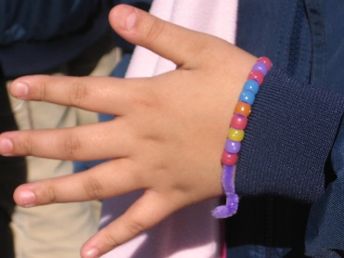

Understanding Ultraviolet (U.V.) Beads

To understand the behavior of ultraviolet (UV) beads, we must first grasp the nature of ultraviolet light. UV light is one of the three main types of light that is given off by the sun. These types include ultraviolet, visible, and infrared light. While visible light is the type you can see, infrared light is the kind that carries heat, and UV light is the type that gives you a tan. Neither UV light or infrared light is visible to the human eye.

As it turns out, the beads used in our experiment are sensitive to UV light specifically. Each bead contains a chemical—called a pigment—that changes color like skin can do when it absorbs UV light. You can buy other substances that are UV sensitive like nail polish that changes color when exposed to sunlight when you go outside. Away from sunlight, the beads return to their original color as they lose their source of energy.

While the beads are designed to absorb UV light, overexposure to UV light can be harmful to many things—including humans. Its effects can be seen by faded paint colors, or even a cracked garden hose that has been left out in the sun. With respect to humans, overexposure to UV light can be harmful to our skin, causing things such as sunburn and even skin cancer. Luckily, wearing sunscreen can greatly reduce our exposure to this harmful UV light.

One cool thing about the beads is that they can even be used to measure the intensity, or strength, of the UV light. The stronger the intensity the UV light, the deeper the colors of the beads. As a result, the beads can be used as a portable UV light detector that can measure the degree of danger due to UV exposure. If your beads look like the ones below, it is time to slap on some sunscreen or head for the shade.

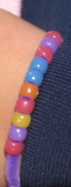
You can even test the effectiveness of different sunscreens by using the beads to see how well they block the UV light. With all of the SPF (Sun Protection Factor) numbers available, you can see for yourself what SPF lotion works best at keeping out the sun's harmful UV rays. Not only are UV beads beautiful, they can be beneficial too.
Contributed by:
​Dr. Tom Brown,
GYSTC Director of Statewide Programs
tbrown@kennesaw.edu

