Kindergarten
Choice Board


Let’s play Tic Tac Toe! Look at the STEM activities below and choose three activities in a straight line (across, up and down, or diagonally) to complete a tic tac toe. Take pictures of your completed squares. If you have any questions about these tasks or need any help at all, please contact me via email (Insert teacher email)

Toy Push and Pull:  Go to this website and watch the video: https://www.youtube.com/watch?v=mEg5GOVpUlE  List five toys that are best pushed. List five toys that you would pull instead of push.  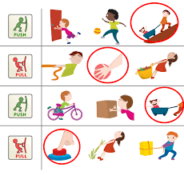  SKP2a | Are the plants different or alike?  Cut out six pictures of different plants from a magazine or newspaper. Glue two plant pictures side by side on a paper. List three ways that the two plants are alike, and three ways that the two plants are different. Repeat with the third and fourth plants, and then the fifth and sixth plants.  SKL2b | Living or Non-Living:  Things which can grow, move, breathe and reproduce are called living things. Things which cannot grow, move, breathe and reproduce are called non-living things.  Look around and find ten living and ten non-living things in your house or yard.  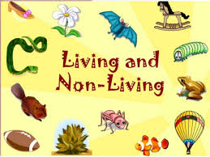  SKL1 a,b
Are the animals different or alike?  Cut out six pictures of different animals from a magazine or newspaper. Glue two of the animal pictures side by side on a paper. List three ways that the two animals are alike, and three ways that the two animals are different. Repeat with the third and fourth animals, and then the fifth and sixth animals.  SKL2a | Day, Dusk, Night and Dawn:  Watch Day Monkey, Night Monkey: https://www.youtube.com/watch?v=ICxLOO9pua0 Make a book about day and night. The book should be at least five pages. Tell about changes that happen in the sky during the day, at dusk, during the night, and at dawn. Please use pictures and words.  SKE1b | Pushes and Pulls:  Play this online game about pushes and pulls:https://education.abc.net.au/res/i/L700/index.html If you were outside playing, think of five things that you might push. Write them down. Now, think of five things that you might pull. Write them down.  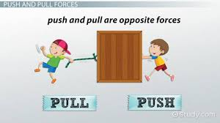  SKP2a
Day Sky, Night Sky  Watch this video: https://www.youtube.com/watch?v=XLQEmPWf2n0  You will be making two drawings. On the first drawing, draw a sky during the day. Put all of the things that you would see in the sky only during the day.  In the second picture, draw a sky during the night. Put all of the things that you would see in the sky only during the night.  SKE1a | Are you My Mother?  Look outside, online or in a magazine for pictures of parent and baby animals. Write three ways that the parent and babies are alike and three ways that the parents and babies are different. You may also draw a picture of a parent and baby animal.  SKL2c | Sorting Objects  Find a jar of buttons, coins, rocks, or a box with pieces of fabric. Take 12 items and put them into two groups based on a physical attribute (Color, size, shape). Take or draw a picture of your classification. Explain what you used to sort the objects.  Now, mix them up and sort the objects into three groups. Take or draw a picture of the new classification. Explain what attribute you used to sort the objects.  SKP1b

