
GYSTC
Standards-Based Choice Board Activities
First Grade
Choice Board

1st Grade

Let’s play Tic Tac Toe! Look at the science and STEM activities below and choose three activities in a straight line (across, up and down, or diagonally) to complete a Tic Tac Toe. If you have any questions about these tasks or need any help at all, please contact me via email (Insert teacher email)

Make a Wind Vane  Make a simple wind vane to show current wind direction.  https://sciencestruck.com/how-to-make-wind-vane    S1E1c | Shadows Galore  Create a shadow by placing objects at various points from the light source.  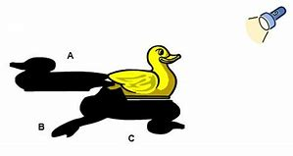  S1P1c | Parts of a Plant  Find a plant outside. Draw and identify the parts – root, stem, leaf and flower.  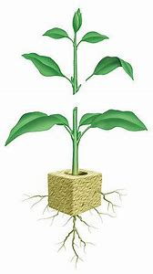  S1L1a
Plant and Animal Differences  The basic needs of plants and animals are different. Use the Venn Diagram to compare and contrast.  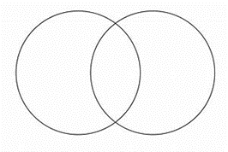  S1L1b | My Weather Log  Create a weather book. Take at least 5 days and go outside and draw what a it looks like outside. Is it sunny, cloudy, or raining?    S1E1a, b, c | Magnet Fun  Find a magnet. Find 10-15 different objects from around your house. Use the magnet to determine if the effects on objects.  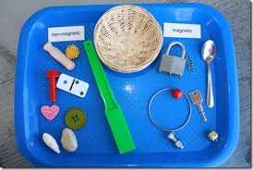  S1P2a, b
My Musical Instrument  Create a musical instrument to create sound.  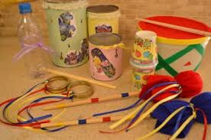  S1P1d | Plant and Animal Needs  Draw a diagram of an animal or plant that shows all of its needs are being met.  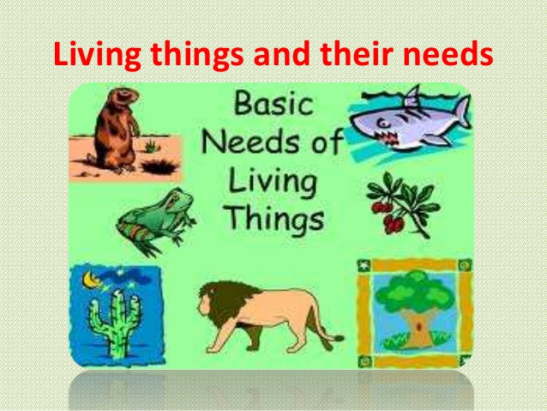  S1L1c | The Seasons of My Tree  Take a piece of paper and fold in half and half again. On the first box, look at a tree outside and draw it. What season are we in? Take the other three boxes and draw the tree over the next three seasons. Make sure you label.  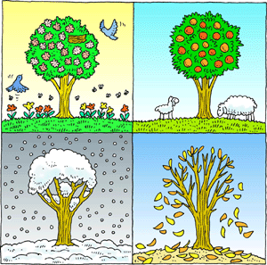  S1E1d

