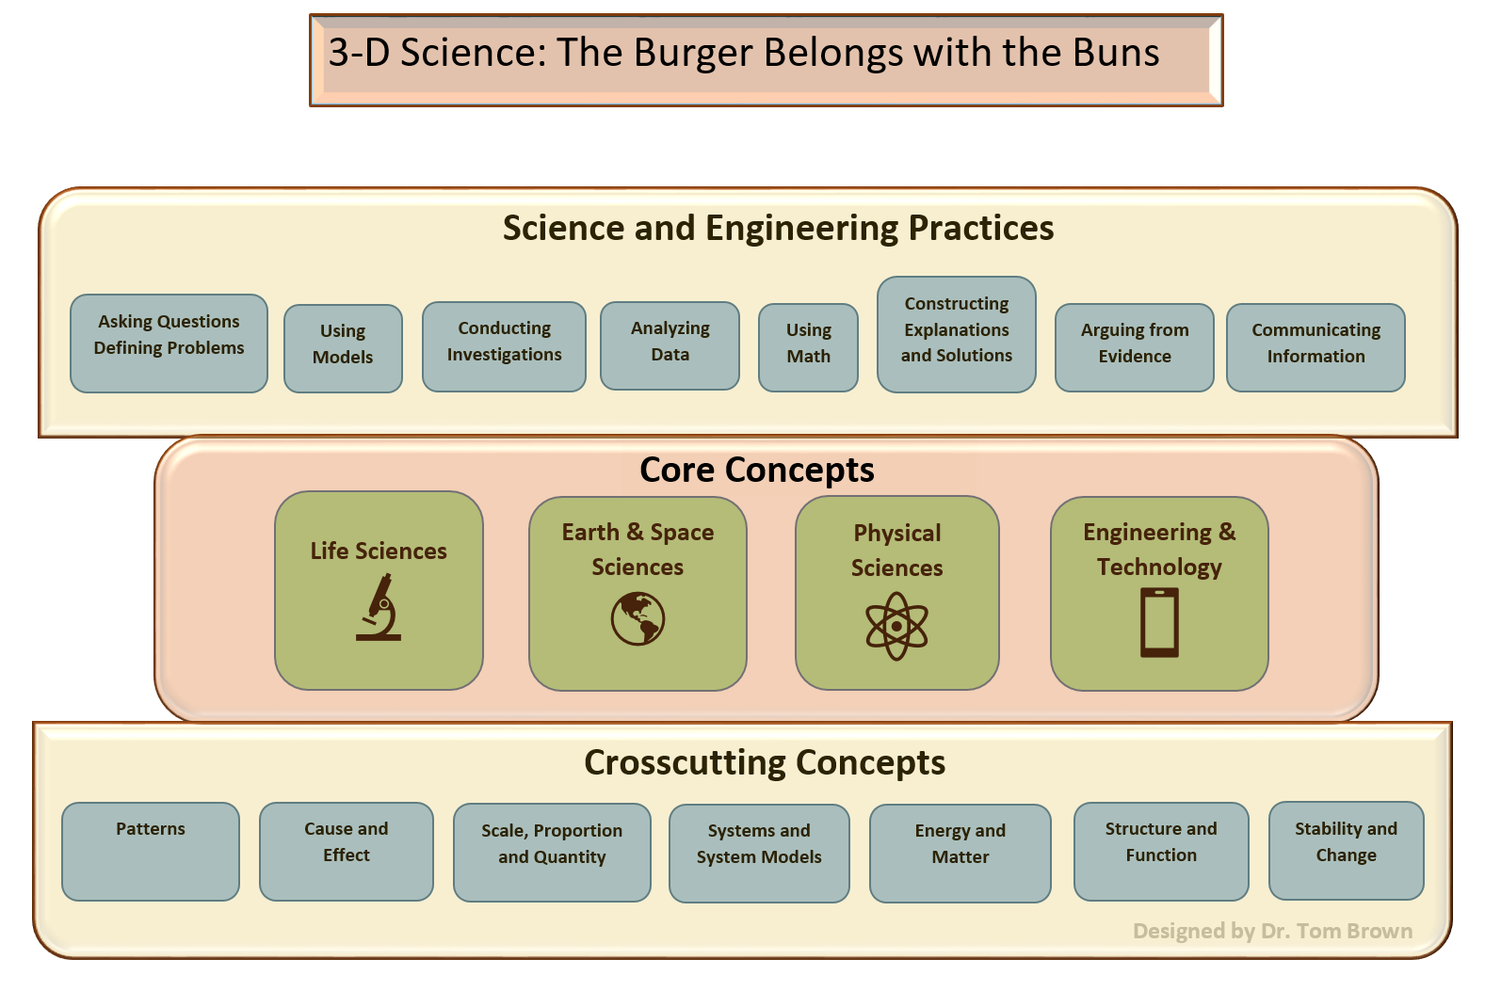

This graphic highlights our new 3-D approach to Science/STEM instruction. It is meant to be simple and to the point. The burger emphasizes the core ideas (meat) that we teach yet underscores how we can incorporate both science and engineering practices and crosscutting concepts (the buns) into this instruction. We know that scientists routinely engage in these practices as they generate, test, and communicate new ideas. It only makes sense that we engage our students of science in similar kinds of practices. Finally, we can always have students consider how the concepts under study link to the crosscutting concepts (or big ideas) of science. While taking time to discuss these big ideas may be new to most of us, there is little doubt that examining things like patterns, causes, and stability can help students see how ideas are connected in our natural and engineered world. The burger really does belong with the buns.

