
Second Grade
Choice Board

Let’s play Tic Tac Toe! Look at the Science activities below and choose three activities in a straight line (across, up and down, or diagonally) to complete a tic tac toe. If you have any questions about these tasks or need any help at all, please contact me via email (Insert teacher email)

Raining in the Mountains  Explore the way rain in the mountains leads to rivers that flow to the ocean.  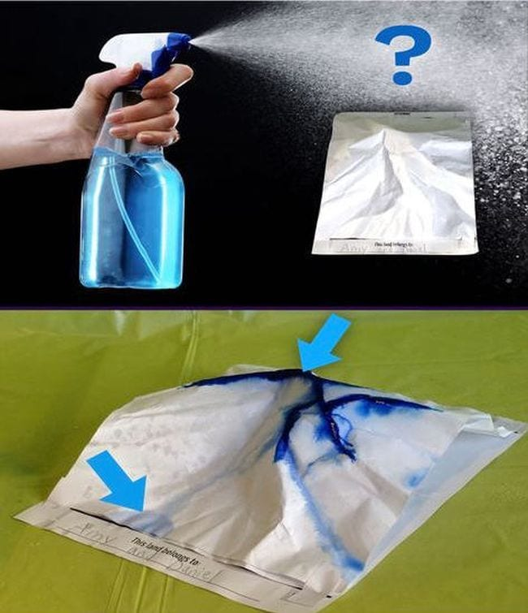  Crumple a piece of paper to create mountain peaks and valleys. Then, fill a spray bottle with water and a drop of food coloring. Spray colored water to create “rain” and see where the water goes. Did the water puddle or change the mountain? How? How else could water change our environment?  S2E3 Earth & Space Science | SunDial Toys and Shadows  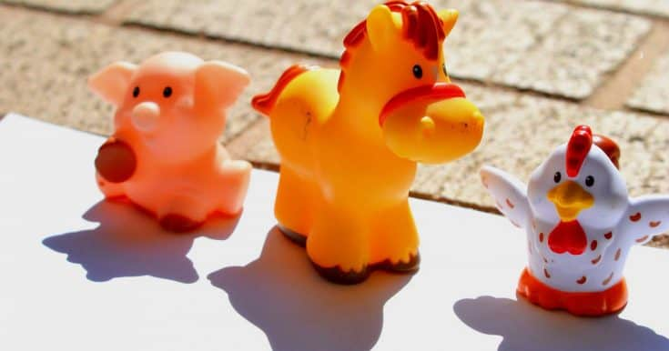  Place a toy on a large sheet of paper on the ground outside. Place rocks on the paper to keep it from blowing away. In the morning, trace the shadow of the toy. Write the time of your tracing.. Two hours later, trace the shadow of your toy again. Write the time of your drawing. Two hours later do the same thing. Continue tracing your toy shadow until the end of the day. What did you observe?  S2E2 Earth & Space Science | Star Light, Star Bright  Using scissors and a piece of paper, cut out a sun about the size of your hand. Tape the sun to a popsicle stick or straw. Hold the sun about 2 inches from your face. What size is it? Have someone hold the sun across the room. What size is the sun now?  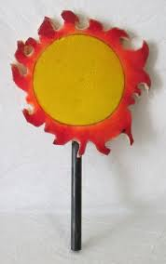  The sun is not the largest star in the galaxy, but it is the closest. Being the closest, it looks the biggest. It’s actually a medium size star and medium size brightness.  S2E2 Earth & Space Science
Pollination In Action  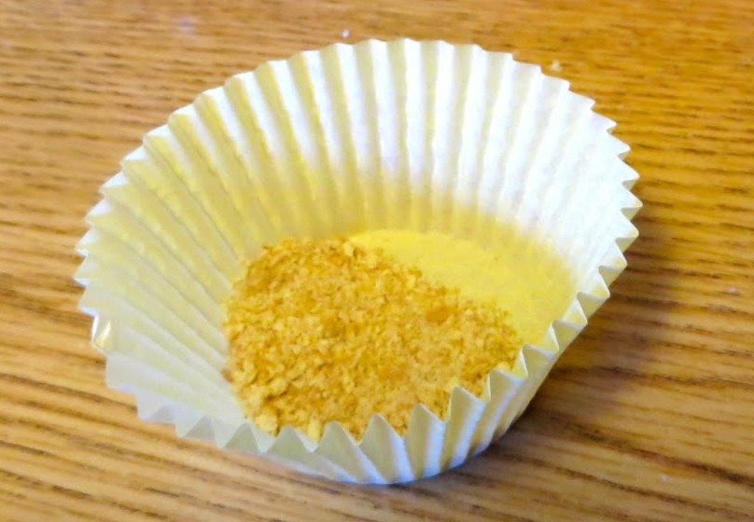  Make a fuzzy “bug” with pom-poms and pipe cleaners, and create “flowers” from cupcake wrappers. Fill the cupcake wrappers with crumbled cheetos. Then, have the insect visit each flower and observe how the pollen grains (cheetos) stick and mix. What happens to the legs (pipe cleaners) of your insect?  Where is the pollen (cheetos) going?  S2L1 Life Science | Butterfly Life Cycle  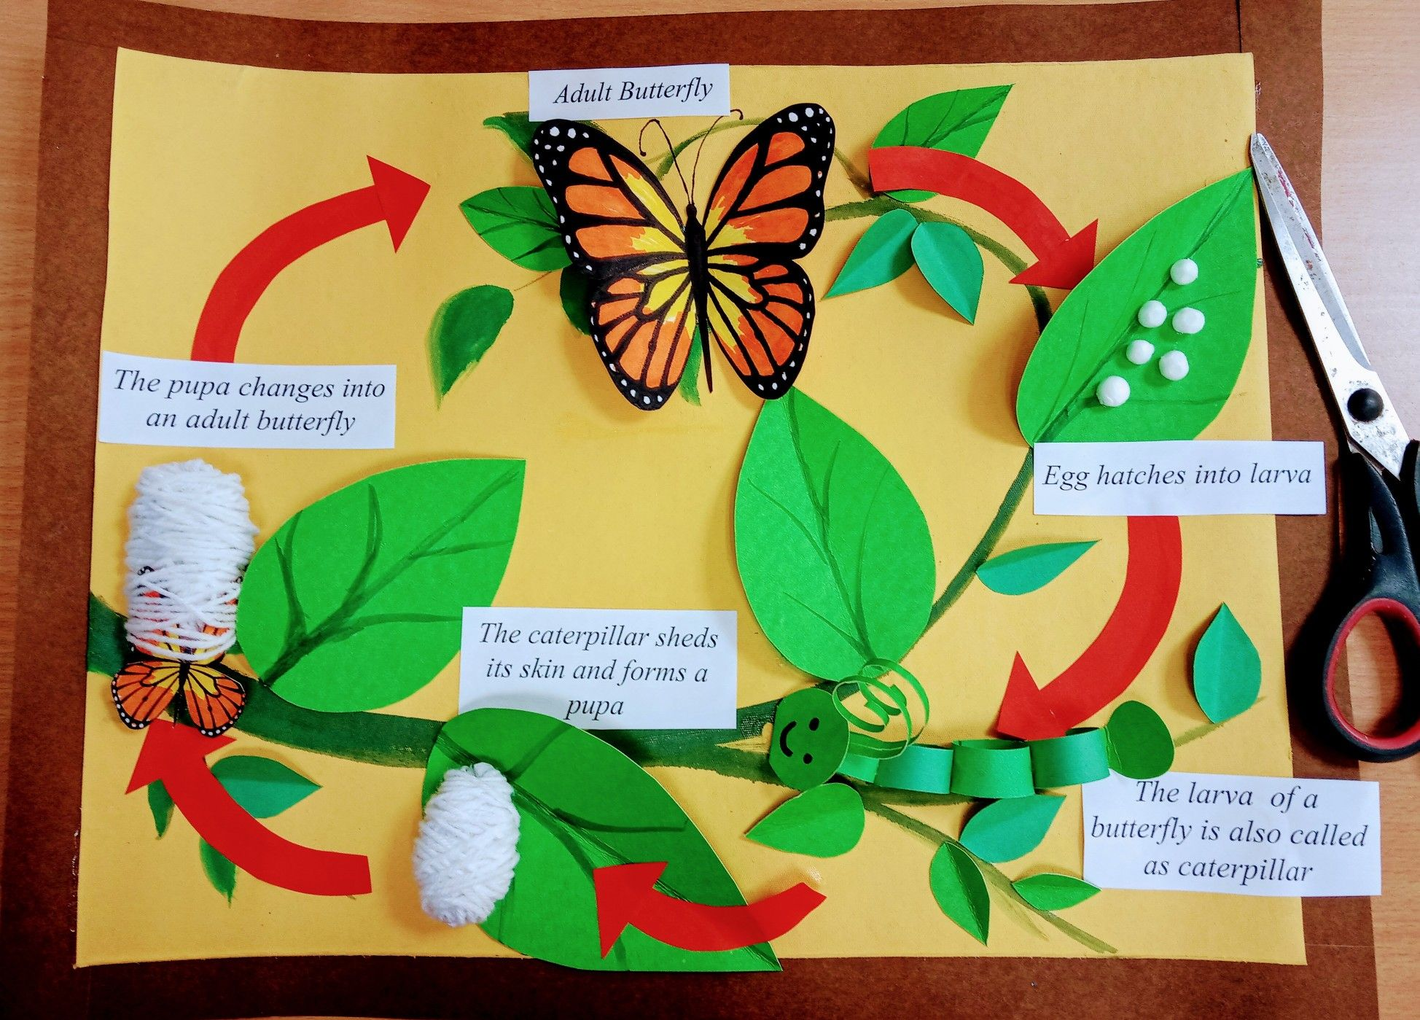  Look up the life cycle of a butterfly. Go outside and gather earthly materials to use to create each stage of a butterfly. A butterfly starts as an egg. The egg grows into a caterpillar or Larva. The caterpillar wraps into a pupa or chrysalis. Finally the adult butterfly leaves the chrysalis.  S2L1 Life Science | Self Sustaining Ecosystem  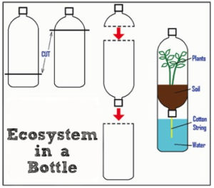  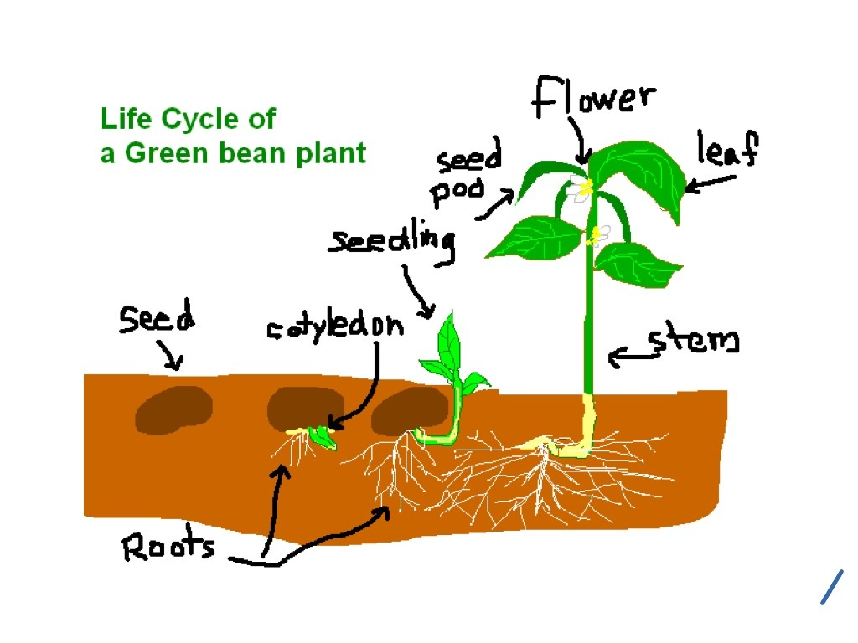  Ask a parent to cut and put together two bottles as shown. Add water and soil. Plant several bean seeds close to the edges of the bottle and replace the lid. Daily, observe the plant life cycle. Draw the life cycle of your plant as it grows.  S2L1 Life Science
The Moving Object  Find a small object in your house and create a device that will move the object. Use household materials such as toilet paper rolls, rubber bands, spoons, etc.  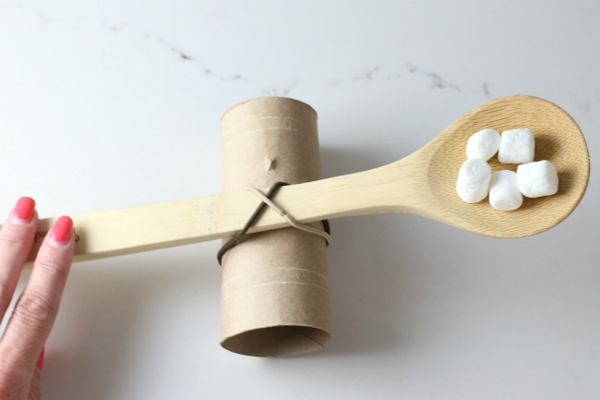  One example would be to build a catapult to move the direction of a cotton ball. Practice pushing or pulling your object from one place to another with your device.  S2P2 Physical Science | Changing Matter  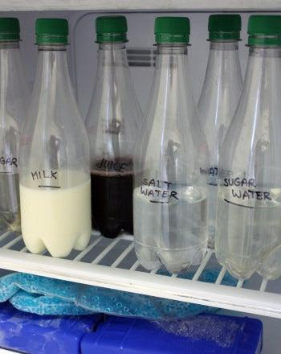  Fill several bottles up with different liquids such as milk, water, sugar water, and salt water. Place in the freezer for two hours. Observe and write down your observations. Place back in the freezer for two more hours. Observe and write down your observations. What happened? Create a T-Chart separating the liquids that froze and the liquids that didn’t.  S2P1 Physical Science | Properties of Crackers  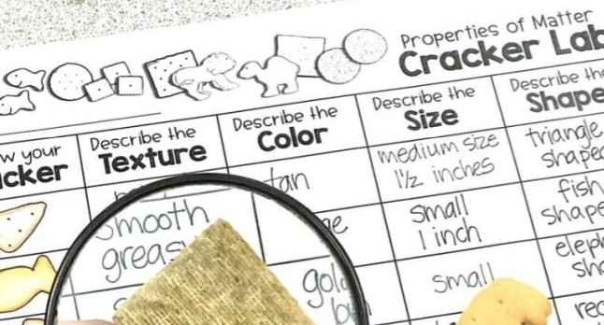  Gather different types of crackers such as goldfish, triscuits, cheese-its, saltines, & animal crackers. Draw a chart placing crackers down the paper. Across the top, write the properties the crackers have, such as, texture, color, size, & shape. Complete your chart by observing each cracker.  S2P1 Physical Science

