
Third Grade
Choice Board

Let’s play Tic Tac Toe! Look at the science and STEM activities below and choose three activities in a straight line (across, up and down, or diagonally) to complete a Tic Tac Toe. If you have any questions about these tasks or need any help at all, please contact me via email (Insert teacher email)

Rock Hunt  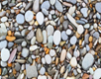  Gather 10 rocks from your yard and record your observations. Record: what color(s) the rock is, for texture, tell if the rock is smooth, bumpy, or rough, and for luster, tell if the rock is dull, shiny, glassy, etc.  S3E1.a | Solar Oven  Use a shoe box or pizza box to make a solar oven (see below). Layer a graham cracker, piece of chocolate, marshmallow, and another graham cracker, and place them into the solar oven in the Sun. Check after a couple hours. Enjoy!  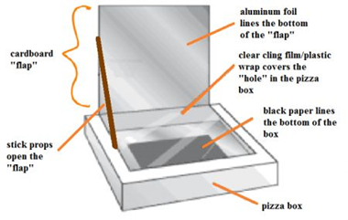  S3P1.c | Hiding Right in Front of You!  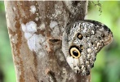  Fold a piece of paper in half. On the fold, draw a butterfly wing, cut it out, and open to make a butterfly shape. Hang a piece of cloth or poster on the wall. Look for a spot that you can make your butterfly look exactly like the cloth. Color your butterfly. Tape it onto the cloth. Challenge someone to see if they can find your butterfly.  S3L1.b
Feel the Heat  Make a simple hot water heater, NASA-style. For directions, go to https://www.jpl.nasa.gov/  edu/teach/activity/feel-the-heat/  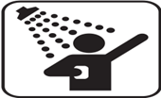  S3P1.c | Effects of Pollution  Go to this website and view the slideshow:  kids.nationalgeographic.com/  explore/science/pollution  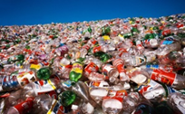  Now, pretend that you are one of those animals and write a letter to a human asking them to help you have a safe home.  S3L2.a | Fossil Book  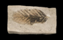  In your book tell: (1) about your sea animal and where it lived, (2) that it died and sank to the bottom of the sea, (3) layers of earth and the remains of other living things built up on top of the deceased animal (4) over time, these layers turned into rock. (5) Over many years, the living thing’s hard parts also turned into rock, (6) your animal is now a fossil. Illustrate your book.  S3E2.b
Let’s Recycle!  The symbols below show that something is recyclable. The number under this symbol tells you what the material is made of. Go on a scavenger hunt and see if you can find items made from the seven different materials that are recyclable.  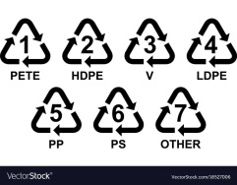  S3L2.b | Make a Fossils  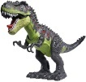  Mix together 1 cup salt, 2 cups flour and 3/4 cup water to make a salt playdough. Divide the dough into six balls and flatten them to make a cookie shape. Take a small plastic dinosaur or other toys and press it sideways into each of the ‘cookies’ to make an imprint of the toy shape. Have an adult bake your fossils at 200 degrees for 45-60 minutes.  S3E2.a | Making Heat    Cover one shoebox with black construction paper, a second with green paper, and a third with white paper. Place all three shoeboxes in the sunlight. Place a bowl of water in each shoebox. Make sure that you use similar bowls and the same amount of water in each bowl. Leave the shoeboxes in the sunlight. Check the boxes in two hours. Which water feels the warmest? Why?  S3P1.a

