Fourth Grade
Choice Board



Let’s play Tic Tac Toe! Look at the science and STEM activities below and choose three activities in a straight line (across, up and down, or diagonally) to complete a tic tac toe. If you have any questions about these tasks or need any help at all, please contact me via email (Insert teacher email)

Food Chain vs Food Web  A food chain shows how the energy from the food is passed on from creature to creature. Food chains always begin with the Sun because that is what plants use for energy. Food chains begin with plants (producers) and end with animals (consumers). Food chains show one possible combination, and food webs show many possibilities at each level. Draw a food chain, and then draw a food web.  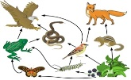  S4L1.b | Who Broke My Pencil?!  Fill a clear glass with water. Place a pencil into the glass at an angle. Look at the pencil from the side.  Is it bent? Next, using a marker, draw an arrow at the top and bottom of a piece of paper. (below) Putting the water in between you and the paper, hold the paper above the glass of water. Slowly lower the paper so that it goes behind the glass. Light travels through air and water at different speeds. This is called refraction.  S4P1.c | Stars and Planets  Watch the following video: https://www.youtube.  com/watch?v=0TMi3Prd7Qg  Write a paragraph explaining about how stars and planets are different and how they are alike.  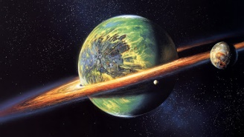  S4E1.c
Vibrations and Sound  Place a hex nut into a balloon.  Shake the balloon gently to make sure that the hex nut goes down to the bottom of the balloon. Blow up the balloon and tie it. Hold the balloon so that the tie  of the balloon is touching the  palm of your hand. Slowly spin the balloon for one minute. Spin the balloon a little more quickly.  What happened?  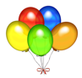  S4P2.a | Moon Log  The moon goes from new moon through all of the different phases back to new moon every 29 1/2 days. Keep a journal for a month of how the moon looks. Write in the date and draw the lighted part of the moon in yellow crayon or colored pencil each evening (or morning). Be sure to draw the lighted side on the correct side. Do you notice a pattern to the changes?  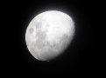  S4E2.b | Smelly Scenario  Skunks are omnivorous, which means that they eat both plants and animals. They eat insects, larvae, earth-worms, grubs, rodents, lizards, salamanders, frogs, snakes, birds, moles, and eggs ,berries, roots, leaves, grasses, fungi and nuts. Think about what would happen if the skunks were removed. What animal populations would get too large? What plants might grow out of control? Write a story about why even skunks are an important part of our ecosystem.  S4L1.c
Cloud Log  There are three main types of clouds. Cumulus clouds are low to mid-level clouds, and are big, white puffy clouds. Cirrus clouds are high level clouds that are thin, feather-like, and wispy. Stratus clouds are low level clouds that are flat and tend to cover much of the sky. They are usually a gray color and may produce light rain or drizzle. Each day for ten days, go outside and look at the clouds, and then sketch them in a journal.  S4E4.c | What Role do we Play?  Go to www.generationgenius.com and watch the video on Ecosystems. Scroll down to the DIY activity. Make the terrarium, and then add some small bugs. Observe your ecosystem for a week.  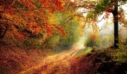  S4L1.a | Flashlight Fun  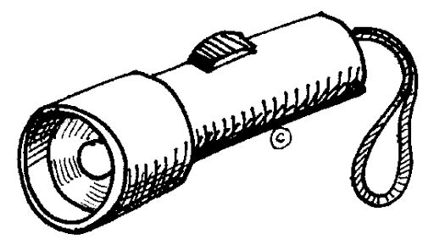  If an object allows light to pass through it, it is called transparent. Windows are transparent. If an object partially allows light to pass through it, it is called translucent, like tissue paper. If an object does not allow any light to pass through it, it is called opaque. Use a flashlight to test objects around your house. Decide if they are transparent, translucent, or opaque.  S4P1.a

