Seventh Grade
Choice Board


Let’s play Tic Tac Toe! Look at the Science activities below and choose three activities in a straight line (across, up and down, or diagonally) to complete a tic tac toe. If you have any questions about these tasks or need any help at all, please contact me via email (Insert teacher email)

Taxonomy & Dichotomous Key  Watch the Brain Scoop video to see how scientists classify candy. https://laughingsquid.com/scientists-attempt-to-classify-different-types-of-candy-to-help-explain-taxonomy/  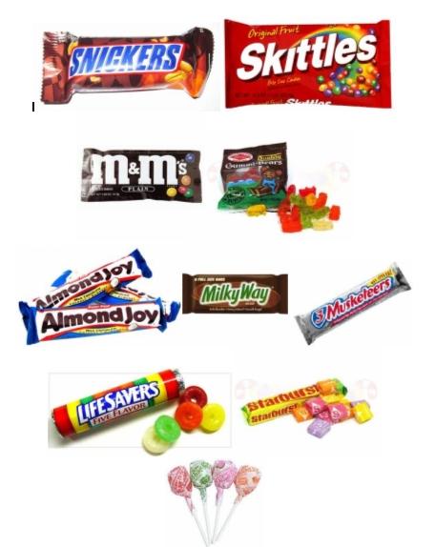  Classify multiple types of candy in different piles and design a graph.  S7L1a Classification | Food Webs/Food Chains  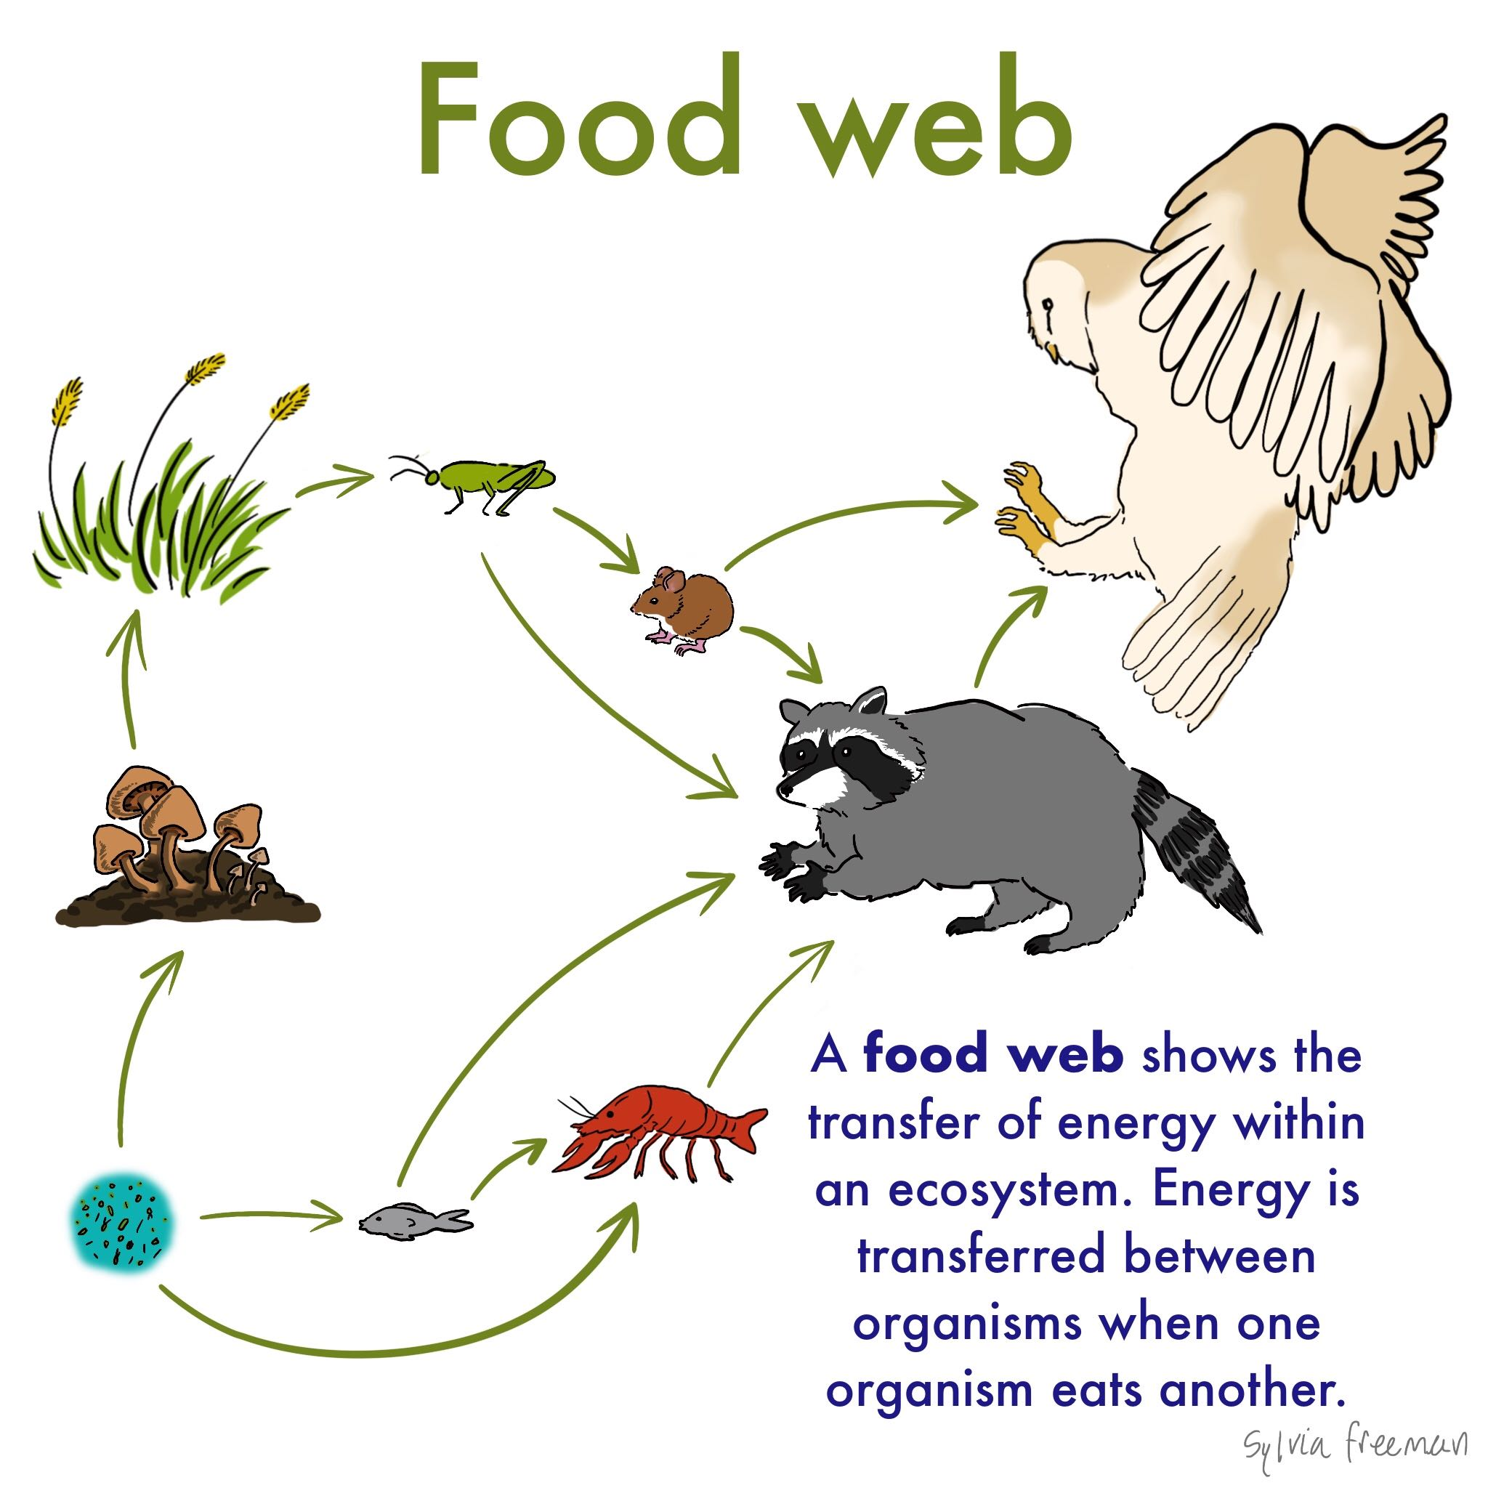  Play the Study Jams! video titled “Food Webs” and then test yourself with the seven questions. How many did you get correct?  http://studyjams.scholastic.com/studyjams/jams/science/ecosystems/food-webs.htm  S7L4a, b, c Ecology | 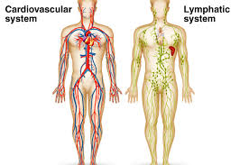  Human Body Systems Working Together  Click on the Science Net Links link below. Discover how the body systems work together by playing the game. Answer the questions on a sheet of paper.  http://sciencenetlinks.com/media/filer/2011/11/11/all-systems-go.pdf  S7L2c Human Body
Homeostasis  Read the article and watch the two video clips. https://www.ck12.org/biology/homeostasis/lesson/Homeostasis-BIO/?referrer=concept_details  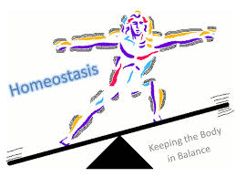  List the ways a snake bite causes homeostasis to be out of balance in the scientist's body.  S7L2b, c Human Body | Natural Selection- Beaks  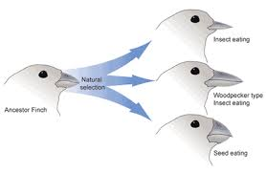  Use the Science Friday link below to design and test your own bird beak. Discover how a bird’s beak has adapted over time. https://www.sciencefriday.com/educational-resources/a-new-beak-evolution-lab/  S7L5b Natural Selection | Self-Sustaining Ecosystem  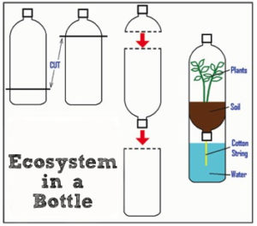  Build your own ecosystem while finding the balance between the water cycle, nitrogen cycle and the carbon cycle. http://spikesworld.spike-jamie.com/science/ecology/c241-02-terrarium.html  S7L4b, c Ecology
Genetic Modification in Plants  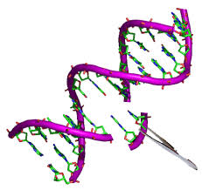  How do genetics play a role in making our plants, or the foods we eat, “better”? Watch the video.  https://youtu.be/rx953M-tpp4  Can you think of any foods that we eat that are genetically modified? Skim through the foods on this link. http://www.pbs.org/wgbh/harvest/coming/coming_lo.html Pick one food listed and research more on how and why that food is genetically modified.  S7L5c Genetics | Cell Division In Cancer Cells  How does the process of cell division affect cancer cells? Watch the video from Mr. Anderson. Take some doodle notes as you listen to Mr. Anderson. https://www.youtube.com/watch?feature=player_embedded&v=LEpTTolebqo  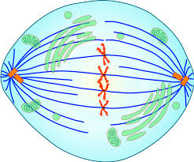  Next, watch the video called, “How do Cancer Cells Act Differently from Normal Cells?”  https://www.youtube.com/watch?v=BmFEoCFDi-w&feature=youtu.be  Answer the question, “Why don't cancer cells just die off?”  S7L2 Cell Processes | Build A Microscope with water  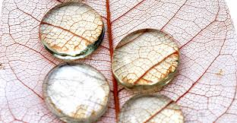  Use the link below to build a microscope using water droplets. Discover new things as you magnify objects.  https://raisinglifelonglearners.com/easy-homemade-microscope/  S7L1 & 2 Tools of A Scientist- Cells

