Eighth Grade
Choice Board

Let’s play Tic Tac Toe! Look at the Science activities below and choose three activities in a straight line (across, up and down, or diagonally) to complete a tic tac toe. If you have any questions about these tasks or need any help at all, please contact me via email (Insert teacher email)

Kitchen Chemistry  Explore how everyday kitchen items react when combined and identify the combination as a chemical or physical change. Place about ¼ tablespoon of baking soda in a bowl then add a few drops of water and observe and record what happens. Was this a physical or chemical change? What evidence leads you to believe this? Then repeat the same process with 3 more liquids such as vinegar, apple juice, or lemon juice.  S8P1d | Movement of Molecules  Make ice cream by gathering these materials:  Half and half, Sugar, Vanilla, Salt, Ice, 1 small zipper bag, 1 large zipper bag  Follow the instructions on this site: https://www.thebestideasforkids.com/ice-cream-in-a-bag/  Once you have made your ice cream identify the state change that took place. How did this occur? Was thermal energy added or lost to make this happen?  S8P1b | Homemade Lens  Lenses are used in many of the products we use daily (ex. Prescription glasses, cameras, laser pointers, etc.), but how do they work? Make your own lens using an recycled water bottle by following the instructions on this site: https://www.science-sparks.com/make-your-own-magnifying-glass/  Is the lens you constructed concave or convex? Draw a picture to show the path of the light as it travels through your lens, and describe how your lens changes the image you see through it.  S8P4g
Echoing Sound Waves  Set up 2 cardboard tubes and a pie pan as shown in the picture below.  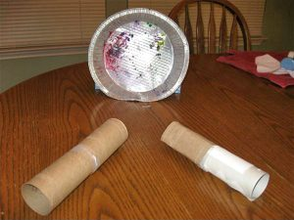  Ask someone to point one tube at the pie pan and speak into it. Place the other tube to your ear and point it at the pie pan as well. Observe and describe the echoes you can hear. Now cover the pie pan with any material (ex. Fabric, paper, etc.) See what you can hear now. Describe how the sound waves change based on the materials used.  S8P4d | Electromagnet  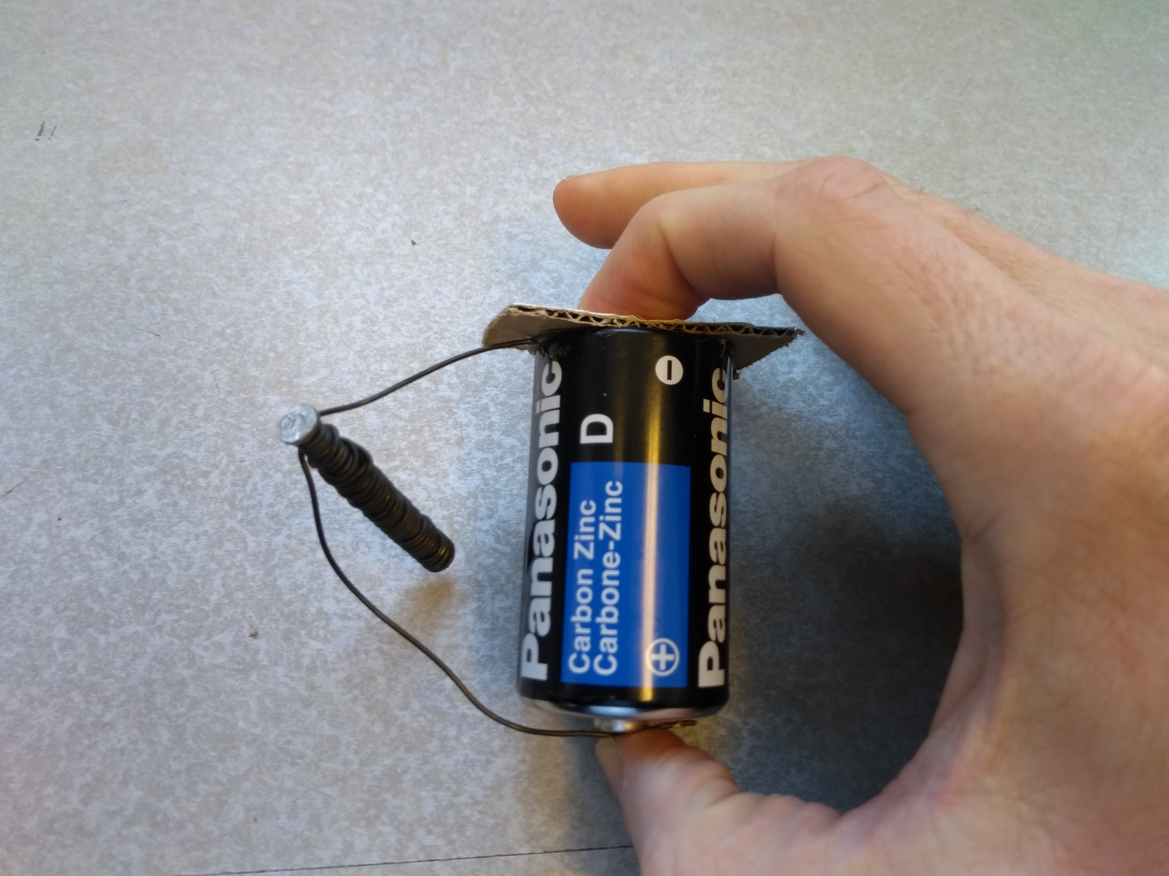  Gather wire, a nail, and a battery. Wrap the wire around the nail and attach it to the positive and negative terminals of the battery as shown in the photo. (Caution: the battery may get hot if held too long.) Now try to pick up metal objects using the electromagnet. Try wrapping a longer piece of wire around the nail, using a larger nail, or more batteries to make the electromagnet. Describe how this affected the strength of your electromagnet.  S8P5c | Stacked Ball Drop  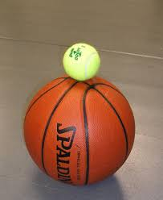  Find two different sized balls (ex. Basketball & tennis ball) Try bouncing each ball by itself by dropping it from the same height and observe their bounce heights. Now stack the balls as shown and drop them from the original height. What did you observe this time? Explain what role Newton’s second law play in this outcome? (Hint: think about how the mass changes when combining the balls.)  A video showing this process:  https://www.youtube.com/watch?time_continue=48&v=2UHS883_P60&feature=emb_logo  S8P3c
Pendulum      Gather string, tape, and a small object such as a bouncy ball. Tape the object to one end of the string and tape the other end of the string to the top of a door frame. Then pull the small object back, touch it to your nose, and release the object. Try not to move as the object swings back towards your face. If you simply dropped the object it will not swing back to touch your face. Why do you think the object is unable to swing all the way back to your face? Draw a picture of the pendulum’s travel path and describe how the pendulum’s potential energy transforms into kinetic energy, and back.  S8P2a | Energy Transformation  Energy transforms all the time; from chemical to mechanical, from electrical to light, from light to thermal. Walk through your house, find at least 5 energy transformations, and describe the energy transformation occurring in each example. (An example may be your kitchen stove turning electrical energy into thermal energy).  S8P2c | Runaway Truck Ramps  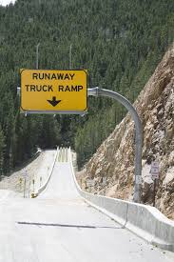  Thanks to their mass large trucks can build up a lot of momentum on mountain roads. Runaway truck ramps are used in case a truck’s brakes fail. These ramps slow the truck to a stop using a steep incline, soft gravel or sand, or even barricades. Find a rolling object (i.e. a toy car, ball, etc.) and design and build a Runaway Truck Ramp to stop this object from rolling. Share your successful design and describe and describe what you used to stop the object as well as where its kinetic energy went.  S8P2e

