A Smooth Cruise is the Way to Move
Forces are the pushes and pulls in our world. By providing pushes and pulls, forces help to get and keep things moving. It also takes energy to provide the forces needed to move stuff. For example, it takes energy from your body to provide the push on your legs needed to walk around. It also takes energy for a ship to push through the ocean.
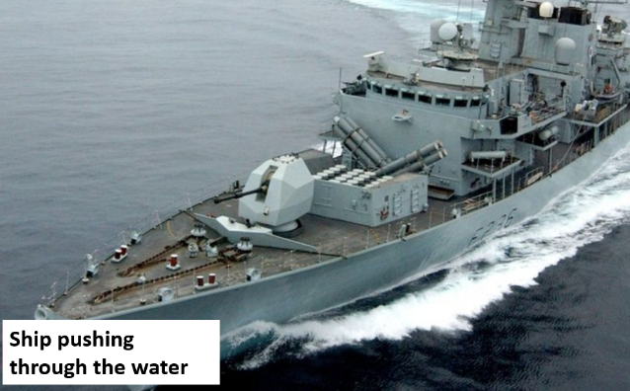

While it always takes energy to move things, it helps if we can design things in a way that makes them use as little energy as possible. This is especially important for things like cars, trucks, and planes that transport things every day. Cars and trucks that use less energy are called energy efficient.
Engineers are always working on new ways to make cars more energy efficient. One thing they search for are new materials that are stronger but lighter since lighter cars take less energy to push them down the road.
Engineers also study how air moves over a speeding car. The more air a car has to push out of the way the more drag there is and the harder it is to move forward. Cars with smooth surfaces and no sharp corners allow the air to flow smoothly over them by keeping the drag as low as possible.
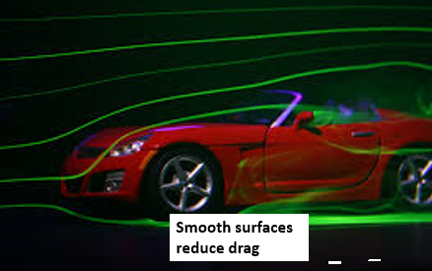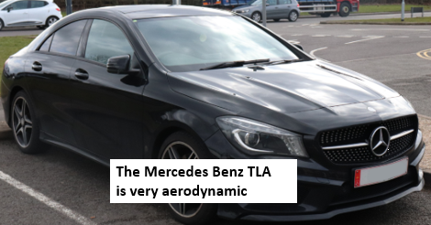
In this STEM Challenge, your task is to build a sleek, energy efficient car that moves down a track as smoothly and quickly as possible. The cars will be powered only by the force of gravity that pulls them down the track.

