Colby Mouse Coding 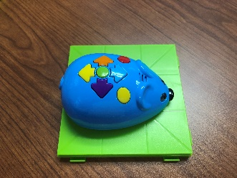
Colby the Coding Mouse provides a great way to introduce younger kids to coding. Put simply, coding is providing a set of instructions that tell a computer what to do. In this case, Colby is the computer that we have to tell exactly what to do. Luckily, coding Colby is pretty simple. You give Colby instructions on how to move by pushing buttons in a pattern. Using clear and colorful arrow buttons, you can tell Colby to move forward and backward, and turn left or right as needed. You also have a clear button, a go button, and an action button. Colby even lights up and makes cool sounds as he moves.
When we first break out the mice, we show and explain each of the codes that Colby can understand.
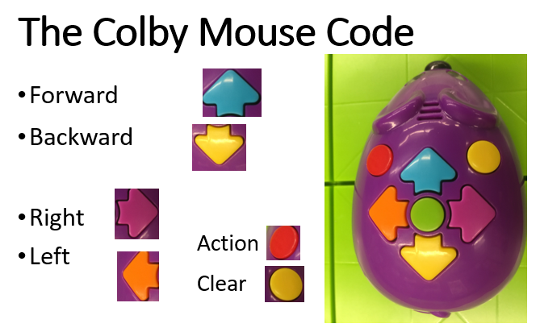

Then we have our students write a simple code using the cards that come with the kit. After doing so, they push in the code, press go, and observe whether Colby follows the correct Code.
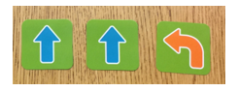
They find out quickly that Colby is really good at following their commands.
This initial activity is super important for illustrating the basics of coding. Kids see through experience that a code is precise, that the computer follows it exactly, and that it’s easy to make mistakes along the way. Although the kids will swear otherwise (mostly because they forget to push the erase button), I have never seen a mouse robot mess-up a code.
After this initial activity, we give each group 6-7 pieces of track, a tunnel, and a piece of cheese. We then challenge them to set up a maze where the mouse has to move from the start to the finish of the maze in order to find her piece of cheese.
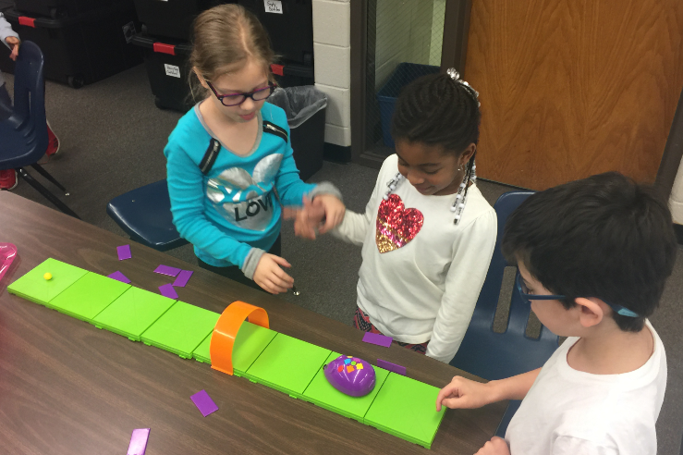
When he does, he squeals with excitement after capturing his favorite snack. Students often start with a simple straight maze 3-4 tracks long but they can move on to add turns and other obstacles when ready. You can use the maze to help students with their number names, counting, and sequencing. If needed, kids can break the code into small chunks and let the mouse respond a couple pushes at a time. The tunnels and purple walls can be added as desired to make the maze more interesting.
For additional lessons, the options are numerous. If you are studying shapes in geometry, you can place different geometric figures at the end of the maze, and have the students complete the code that will get the mouse to the figure.

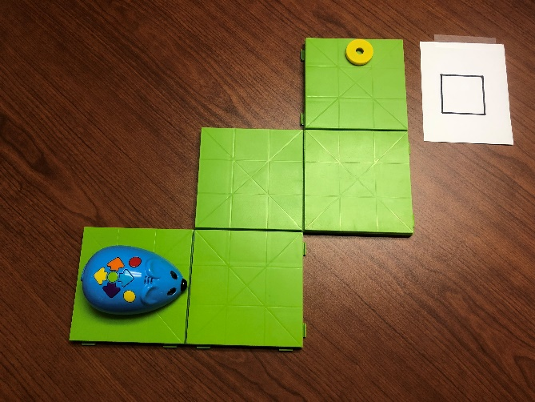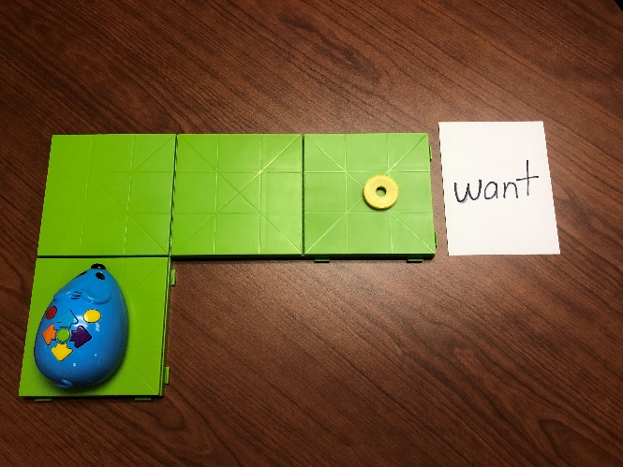
Once there, they must identify the name of the figure and check their work. The same framework can be used to place key sight words at the end of each maze. When Colby completes the maze, students flip over the targeted word and sound it out together.
Finally, you can set up whole series of mazes for students to rotate through when you are practicing key skills or concepts. Toward the end of kindergarten, we have students use a series of mazes to complete simple math sentences that align with each maze. In this case, left and right turns are used to represent addition (+ sign) and backwards can be used to represent subtraction. As always, Colby (and the kids) are rewarded with a piece of cheese upon successful completion on the challenge.
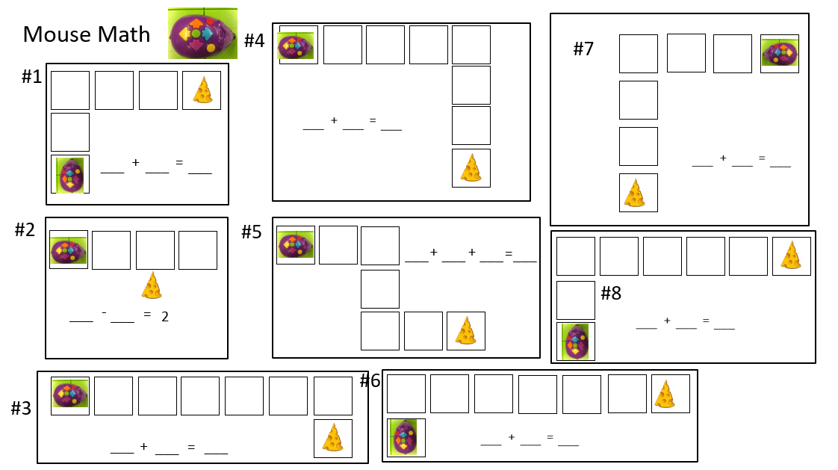

Teacher Notes:
While we might think that Kindergarten and 1st grade are too early to talk about coding we should recognize the extent to which coding in all around us. The results of coding are everywhere. Our phones, watches, cars, and devices all contain computers that rely on code to make them work. Young students can definitely understand that a code is a set of instructions that tell a computer what to do. They can also learn to appreciate the importance of being precise and careful. In reality, most computer codes (languages) are much simpler than the English language they are working so hard to master.
Colby the Coding Mouse provides a tactile and visual way for kids to see the importance of providing instructions that are precise and sequential. As a mini-computer, Colby follows instructions exactly. In doing so, explorations with Colby offer a great chance for kids to be immersed in basic concepts of coding.
Colby the Coding Mouse can be purchased separately on Amazon or with an 83 piece activity set that is excellent. We stretch our budget by buying a separate mouse for each activity set and then we split up the track, walls, and tunnels to make two sets. The only thing you have to do is find some yellow ring or ball magnets to substitute for the cheese wedge that comes with each kit. Combining 3 activity sets, and 3 extra mice you can finagle a class set of 6 mouse activity sets for a cost around $180 dollars. But even one activity set and one additional mouse can get you up and coding with the kiddos for about 60 bucks.
As an alternative to Coding Mice, BeeBots are a larger version of the essentially the same thing. We prefer Colby’s though because they are significantly cheaper and they take up less space in your classroom.
Good luck with your Colby’s and your introduction to coding with your kiddos.

