Drag and Drop (Coding) Rocks
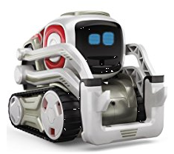
You can program Cozmo with
Drag and Drop Coding

While binary (machine) code provides the basics in a form that computers can understand, this fundamental code is hard for humans to read and writing in binary is both time consuming and clumsy. Fortunately, we have developed a relatively simple coding language that relies primarily on graphics and visual relationships. This language is known as drag and drop, or block, coding. With drag and drop coding, you program a computer by dragging puzzle-like pieces together in the way that you want your computer to function. While the dragging and dropping can seem like a game, you can actually get computers to do some amazing things using this simple language.
Using drag and drop coding, you can program robots or animated characters to move, look, and sound the way you want them to. You can also get them to repeat things by including something called loops and you can even get them to make choices by adding if-then conditions to your program. Finally, you can collect, organize and calculate data if you need to by adding a variable or two to the program.
Scratch (and Scratch Junior for younger kids) is probably the most well known drag and drop computer language. It was developed by Massachusetts Institute of Technology (MIT) and it is super cool and easy to use. Using Scratch, you program animated characters known as sprites to do things on your computer or iPad. One nice thing about it is you can see right away whether your program is doing what you planned on. While Scratch is a great place to start, other cool robots that use drag and drop coding include Sphero, Lego Mindstorm and the incredible and loveable Cozmo.
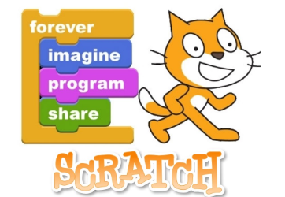
If you want to be a professional computer programmer, you will also have to learn at least one or two higher level programming languages. These languages, often called source codes, provide the detailed set of instructions that define how the code should be written and formatted. Like spoken languages, each computer language has its own set of rules, or syntax, that determine the specific structure of the language. These rules dictate how each language is put together in order to convey information to a computer. While thousands of computer languages have been developed, some of the most popular coding languages include Java, HTML, Python, PHP, C++, JavaScript, and Ruby.

