Name(s)___________________
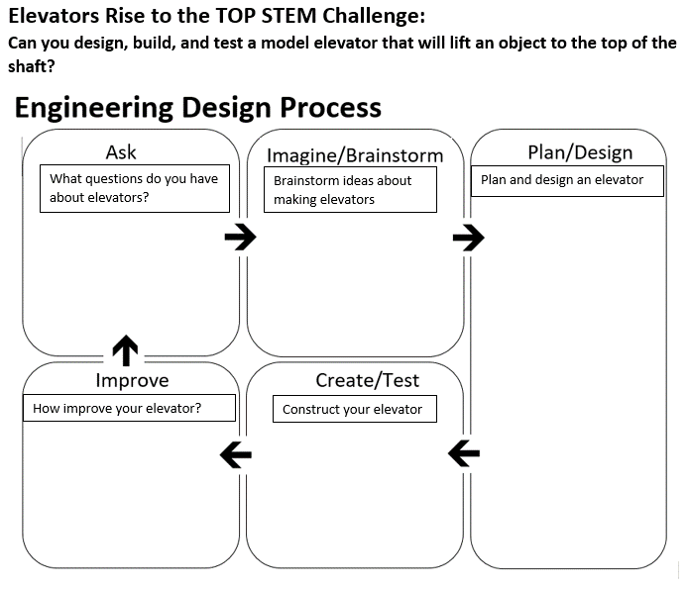How did you measure the effectiveness of your elevator? Record your measurements below.

Explain why elevators are such a useful machine.

