**Engineering Design Process**



1. Ask: What is the challenge? What are the constraints?

2. Imagine: Brainstorm ideas. Choose the best one.



3. Plan/Design: Draw a diagram. Write a procedure. Gather materials.

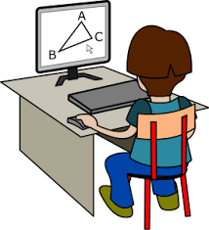



5. Improve: Discuss improvements. Repeat steps after making changes

4. Create: Follow the plan. Build a prototype. Test it out.

3. Plan/Design:



Improve