Name(s) ______________________________
Can you design, build, and test a structure made out of rocks that has a useful purpose?
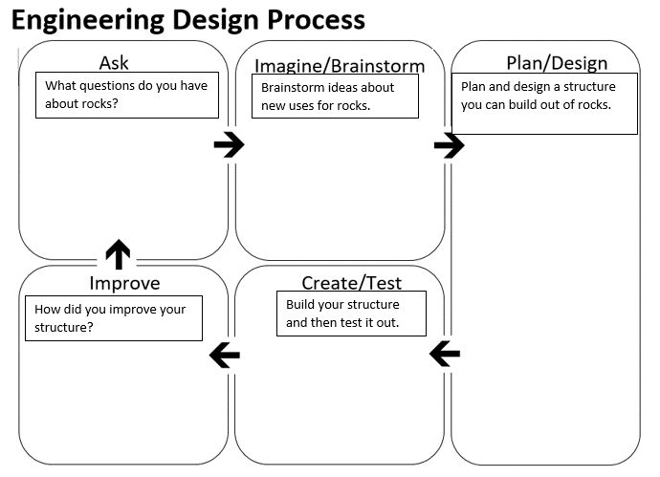
Describe how your rock structure serves a useful purpose.

If you had to build it again, what is one way you would try to improve your structure?

