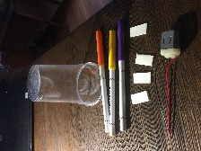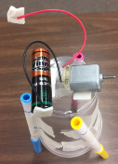
Title: Scooter Bot STEM Challenge
Estimated Time: 1-2 periods
Core Ideas (GSE Standard and elements):
S2P2. Obtain, evaluate, and communicate information to explain the effect of a force (a push or a pull) in the movement of an object (changes in speed and direction). a. Plan and carry out an investigation to demonstrate how pushing and pulling on an object affects the motion of the object. b. Design a device to change the speed or direction of an object.
S4P3. Obtain, evaluate, and communicate information about the relationship between balanced and unbalanced forces. a. Plan and carry out an investigation on the effects of balanced and unbalanced forces on an object and communicate the results.
S8P3. Obtain, evaluate, and communicate information about cause and effect relationships between force, mass, and the motion of objects.
b. Construct an explanation using Newton’s Laws of Motion to describe the effects of balanced and unbalanced forces on the motion of an object.
Science and Engineering Practices:  Planning and Carrying Out Investigations: Conduct an investigation and/or evaluate and/or revise the experimental design to produce data to serve as the basis for evidence that meet the goals of the investigation.  Constructing Explanations and Designing Solutions:  Apply scientific ideas or principles to design, construct, and/or test a design of an object, tool, process or system. | Crosscutting Concepts:  Energy and Matter: Flows, Cycles, and Conservation  Within a natural or designed system, the transfer of energy drives the motion and/or cycling of matter.
STEM Challenge Overview:
The initial task in this challenge is for students to use the mechanical energy produced by a small motor to move the whole Scooter Bot. This is a challenge because, initially, the smooth motion of the motor shaft may not be sufficient to overcome the frictional forces keeping the Scooter Bot in place. Students must plan how to convert more of the (mechanical) movement of the motor into movement of the robot.

Ask | Allow the students to construct the Scooter Bot using the materials and directions provided. Let them complete the circuit so that the motor turns the shaft. They can observe that the unbalanced fore provided by the motor is generally not sufficient to make the entire Scooter Bot move.  Encourage them to ask questions regarding the problem that must be overcome. As needed, emphasize that the force generated must be enough to overcome the frictional forces between the Scooter Bot legs and the surface on which it stands.
Imagine/Brainstorm | Students brainstorm ideas that could serve as possible solutions that could allow the Scooter Bot to move. After doing so, they should consider the strengths and weaknesses of each idea before deciding on which idea they think will provide the best solution.
Plan/Design | Students plan an organized approach to solving their problem. This may include a design (sketch) of the robot and/or a procedure as well as a list of any additional materials they may need to solve the problem.
Create/Test | Students follow their plan, modify their Scooter Bot and create a potential solution to their problem. Once it is created, students test their solution in a measureable way to evaluate the effectiveness of their solution.
Improve | After discussing and evaluating their results, students improve their solution and re-test if possible.
Teacher Notes:
Forces are interactions between objects that cause a push or a pull between them. We can use pushes and pulls to move objects. For example, to walk across the room I have to push on the floor with my feet. Similarly, if I want to catch a baseball in my glove, I have to exert a force to stop it. Otherwise, it flies right past me.

In last couple of centuries, humans have gotten much better at using forces to push things around. For example, we’ve learned how to make engines that provide push by converting the energy from gasoline into mechanical energy that pushes. These kind of engines are called combustion engines and both cars and motorcycles use combustion engines to provide their push. We have also learned how to get the push from batteries that push electricity through a circuit. As this electric energy moves through a circuit, it can easily be changed into other forms of energy like light, heat, or sound depending on what you need.

For middle school students, you may choose to use this challenge to discuss Newton’s 3 laws of motion that describe the relationship between an object, the forces acting on it, and its motion in response to those forces. Newton’s first law states that that an object at rest tends to stay at rest, and an object in motion tends to stay in motion. Motion (or lack of motion) cannot change without an unbalanced force acting on it. Newton’s 1st law is normally considered to be the definition of inertia. Since the Scooter Bot starts out motionless, an unbalanced force is needed to propel it into motion. Fortunately, the Scooter Bot includes a motor that converts electrical energy into mechanical energy which makes the shaft of the motor spin. Once the simple electric circuit is closed, the motor shaft begins spinning providing an unbalanced force that may (or may not be) sufficient to move the Scooter Bot. The force generated must be enough to overcome the frictional forces between the Scooter Bot legs and the surface on which it stands.

The initial task for students is to use the mechanical energy produced by the motor to move the whole robot. Since the smooth motion of the motor is usually not sufficient to overcome the frictional forces, they must plan how to convert more of the (mechanical) movement of the motor into (mechanical) movement of the robot. If time permits, this can be totally open-ended where students choose a variable that they think might be important and then test it out to see if it makes a difference. For example, they can change the placement of the motor or battery, change the position or number of legs, or tape the markers inside the cups.
In any event, one effective change can be to add a piece of cardboard or a piece of pencil eraser (small piece cut lengthwise) to the shaft. This increases the amount of mechanical energy (in the form of vibrations) transferred from the shaft to the Scooter Bot and it is usually enough to get it moving. Students can also add a penny or other coin to the piece of tape to increase this effect.
Once students get their bot moving, they can tape the tops off of the pens and use the Scooter Bot to draw a picture which outlines it’s movement. They can also modify variables to change/improve their picture if time permits. In wrapping up the challenge, have students discuss how they were able to use the mechanical energy produced by the motor to move the whole robot. As needed, emphasize that, through the mechanical energy produced by the spinning motor, an unbalanced force was produced to propel the Scooter Bot into motion. They can also evaluate the artistic patterns produced by the moving pens. Rather than distinct lines being produced, the movements often produce a series of dots.
With respect to crosscutting concepts, the Scooter Bot provides an excellent example of a simply designed system where multiple transfers of energy drive the motion of the system. Chemical potential energy from the battery is transformed into electrical energy which is then transformed into mechanical energy to move the motor and the Scooter Bot.
Materials Needed (per group:
1 AA battery
Miniature DC Motor (cost about $1.00 each)
Felt tip markers (3-4)
Double sided adhesive foam squares (6) (Dollar Store)
Plastic Cup
Masking and Duck Tape

Scooter Bot STEM Challenge:
Can you use the mechanical energy (push) produced by a motor to move your Scooter Bot and allow it to draw a picture?
Constructing your Scooter Bot:
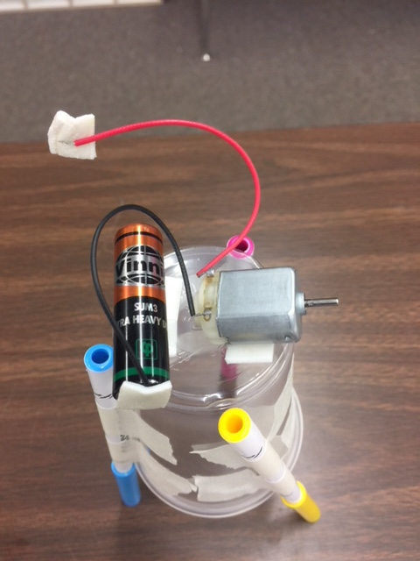
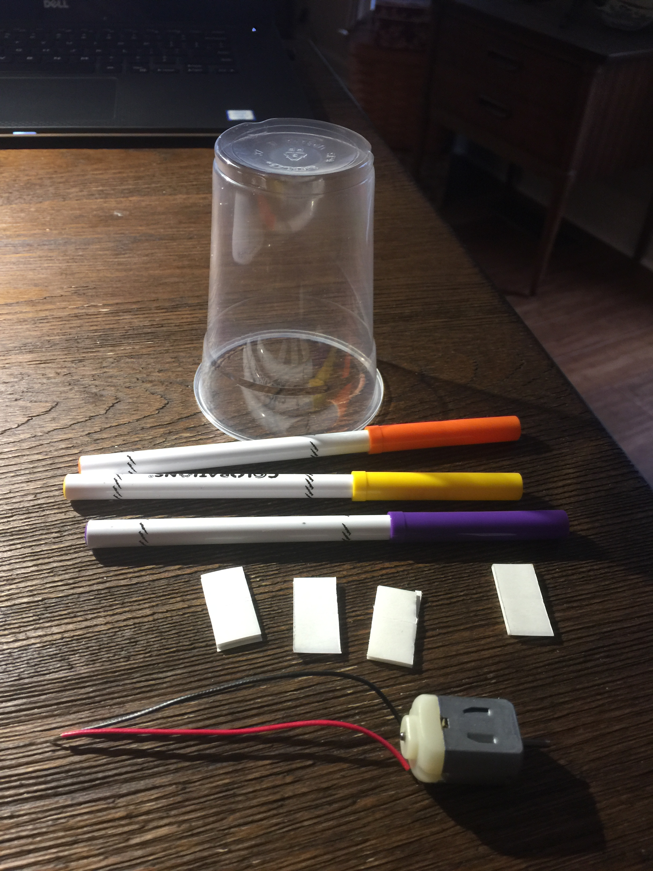
- Tape your 3 pens in a triangle with the caps on the bottom.
- Using adhesive squares, tape your motor to the top of the cup. The motor should hang over the end about ½ inch.
- Using adhesive squares, tape your battery to the top of the cup.
- Using an adhesive square, tape the black wire to the
negative part of the battery.
- Using an adhesive square, tape the red wire to the positive part of the battery. Observe the motion of the motor.
Drawing with your Scooter Bot:
- Choose a variable that you think might increase the amount of mechanical energy (in the form of vibrations) that is transferred to the Scooter Bot.
- If this variable fails to move the Scooter Bot, try adding piece of pencil eraser or a piece of cardboard to the shaft (like a propeller). As an alternative, you can add a piece of tape with a penny or dime attached to it.
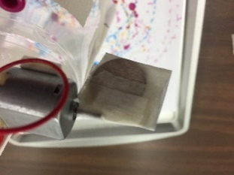
- Once you get your Scooter Bot moving, take the tops off your pens and place the Scooter Bot on a piece of paper. Observe how the motion of the Scooter Bot creates a design on the paper.
- Change one more variable that you think will change (improve) the movement of the Scooter Bot and the design on your paper.
- Turn your Scooter Bot back on and observe.
Evaluating and Improving:
- As a group, discuss how you were able to use the mechanical energy produced by the motor to move the whole bot. Explain how the changes that you made impacted the movement of the Scooter Bot.
- Finally, evaluate the artistic patterns produced by the moving pens. Were distinct lines produced or did the movements produce more of a series of dots? What might the patterns tell you about the quality of motion that is produced?

