[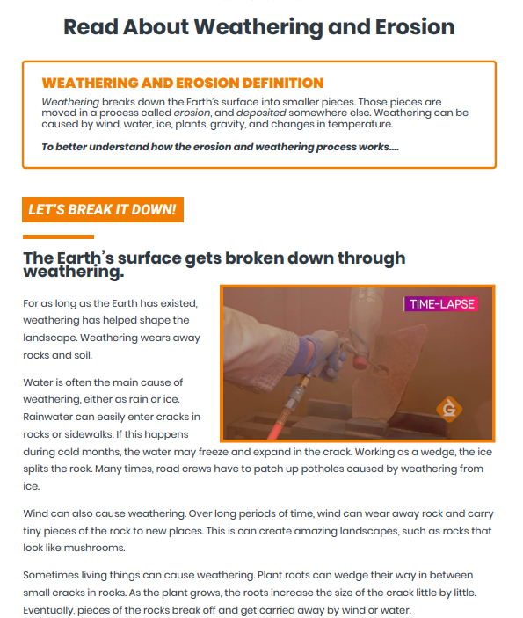](file:///C:/Users/GYSTC/Documents/GYSTC%20@%20South%20Georgia%202022-2023/3rd%20Grade%20Science%202022-2023/S3E1/S3E1c/S3E1.c%20LP%20Weathering%20and%20Erosion.docx)



