**Name: _______________________**

**Date: ________________________**

**Oh, What a Tangled Web!**

A **food chain** shows how **energy** moves through a set of organisms. Here is a food chain example:

j0233510 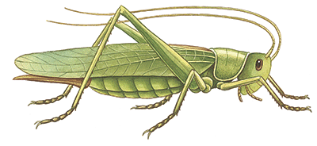 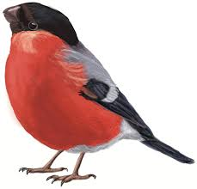

Sun 🡪 Plant 🡪 Grasshopper 🡪 Bird

In this food chain, the plant used the energy from the sun to make food. This process is called photosynthesis. Since the plant makes its own food, we call it a **producer**. When the grasshopper ate the plant, it received energy from the plant (food). The grasshopper was then eaten by a bird. The bird received energy from the grasshopper (food). Organisms that eat other organisms are called **consumers**.

Make your own food chain below:

j0233510 _______ _______ _______

Sun 🡪 Producer 🡪 Consumer 🡪 Consumer

Food chains usually have a **decomposer** in them, too. A decomposer breaks down dead plants and animals, and animal poop, and returns the nutrients to the soil. Decomposers can be things like worms, mushrooms, beetles, and bacteria.

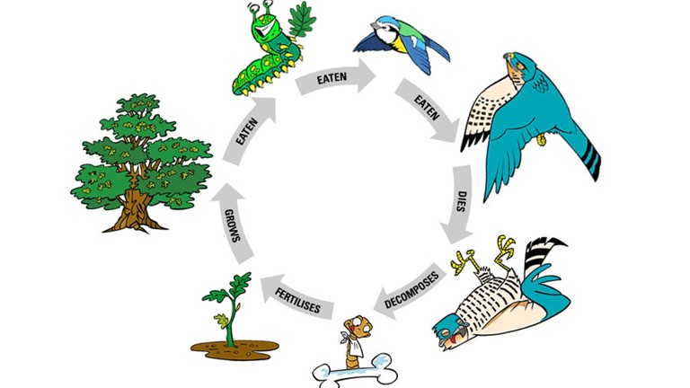

When many food chains are connected, they form a **food web**. For example, if you had grass, a mouse, a bunny, a snake, and a hawk you could make these food chains:

Sun 🡪 Grass 🡪 Mouse 🡪 Snake 🡪 Hawk

Sun 🡪 Grass 🡪 Bunny 🡪 Snake 🡪 Hawk

Sun 🡪 Grass 🡪 Bunny 🡪 Hawk

Sun 🡪 Grass 🡪 Mouse 🡪 Hawk

MCj03083760000[1]And make this web:

j0344852

j0330599

j0233510j0278916

j0250168

Directions: Draw your own food web below. Be sure to include the Sun, at least one producer, and four consumers. Take it a step further and add a decomposer if you are up to the challenge!