[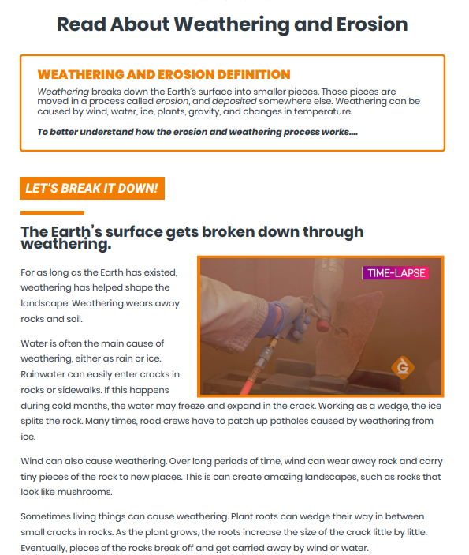](file:///C:\Users\GYSTC\Documents\GYSTC%20@%20South%20Georgia%202022-2023\3rd%20Grade%20Science%202022-2023\S3E1\S3E1c\S3E1.c%20LP%20Weathering%20and%20Erosion.docx)



