Balloon Racers Pre/Post Test

- What force do you think is pushing the balloon racer forward in the photo below?

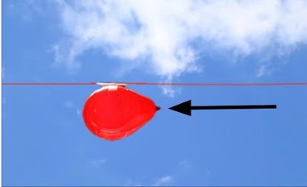
- air resistance
- friction
- gravity
- pressurized air

- How might you calculate the speed of a balloon racer (or any other object)?
- Distance x Time = Speed
- Distance ÷ Time = Speed
- Time x Distance = Speed
- Time ÷ Distance = Speed

- If a balloon racer traveled 5 meters in 2.7 seconds, what is the balloon racer's speed?
a. 0.54 meters per second
b. 13.5 meters per second
c. 1.85 meters per second
d. 7.7 meters per second

- If a balloon racer traveled 5 meters in 1.3 seconds, what is the balloon racer's speed?
a. 0.26 meters per second
b. 6.5 meters per second
c. 6.3 meters per second
d. 3.85 meters per second

- Have you ever thought about being an engineer?
- Yes
- No

Balloon Racers Pre/Post Test Answer Key
1. d
2. b
3. c
4. d

