In-Class Field Trip:
“Bee” a Pollinator

Estimated Time: 1 hour
GSE Standard and element(s):

S2L1. Obtain, evaluate, and communicate information about the life cycles of different living organisms.
c. Construct an explanation of an animal’s role in dispersing seeds or in the pollination of plants.

Supporting Standards:
3.MDR.5.1 Ask questions and answer them based on gathered information, observations, and appropriate graphical displays to solve problems relevant to everyday life.

ELAGSE3RL1 Ask and answer questions to demonstrate understanding of a text, referring explicitly to the text as the basis for the answers.

ELAGSE3SL4 Report on a topic or text, tell a story, or recount an experience with appropriate facts and relevant, descriptive details, speaking clearly at an understandable pace.

Science and Engineering Practices:  Developing and Using Models  Develop and/or use a model to generate data to test ideas about phenomena in natural or designed systems, including those representing inputs and outputs, and those at unobservable scales. | Disciplinary Core Idea:  Engineering, Technology, and the Application of Science  Developing Possible Solutions
Crosscutting Concepts:

Systems and System Models
A system can be described in terms of its components and their interactions.

Authentic Scenario (Phenomena):  Show students a photograph of a bee.  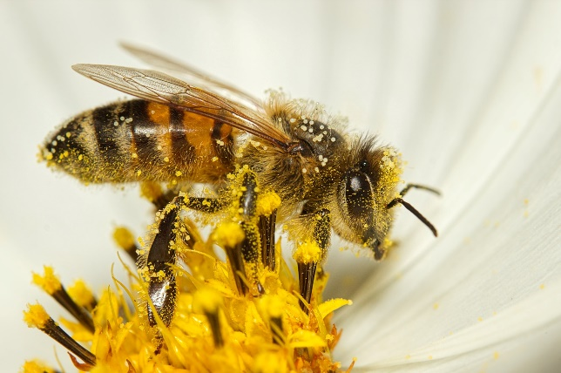 | Vocabulary:  - honeybee  - pollen  - pollination  - redesign  - engineer  - entomologist
Guiding Questions:

What is pollination?
Why are pollinators so important?
How can we help pollinators?

Materials Needed:  One for each student:  - Honeybee Template  - 3 pipe cleaners  - 2 muffin cup liners  - Small amount of powdered sugar (place in one liner)  - Amall amount of cocoa powder (place in other liner)  Additional material supply for redesign:  - Play-Doh  - pipe cleaners  - cotton balls  - tape  - foam | Safety Considerations:  - Encourage students to observe honeybees outside in a natural setting such as a pollinator garden from a distance. Students need to understand that honeybees do sting.
Technology Integration:

- Students can watch a live honeybee webcam and make observations: https://www.ega.edu/about/sustainability/bee-campus/bee-cam.html

Literacy Connections:

- The Honeybee by Kirsten Hall

5E Stage | Student Activities  How will students engage actively in the three dimensions throughout the lesson?  Teacher Activities  How will the teacher facilitate and monitor student learning?
Engage | Show the students the video Honey Bees Close Up Collecting Nectar: https://www.youtube.com/watch?v=YZXcksB-Iks  Ask students what they notice, observe, and wonder. Ask students for their observations and thoughts from the video.
Explore | 1. Have students cut out around the bee’s body (template below lesson). Share that honeybees are insects and ask how many body parts they have. Honeybees are insects and have three body parts: head, thorax, and abdomen.  2. Insects have 3 pairs of legs for a total of 6 legs. Have the students add the 3 sets of pipe cleaners by pushing them through the paper and folding over to make a total of 6 legs.  3. Use the two muffin cup liners as two flowers. Place powdered sugar or something similar in one and cocoa powder or something similar in the other.  4. Allow your honeybee to “visit” one flower. Make sure the legs touch the powdered sugar. The powdered sugar represents POLLEN. Bees visit flowers in search of nectar and pollen as food. “Fly” your honeybee to the next “flower” and let it land.  5. What do you notice? Did the bee transfer any “pollen”? Make observations. Write down your observations. Why do you think this happened? Why is this important?
Explain | Ask students to explain the process that they just completed. Explain that this is called pollination.  Read the book The Honeybee by Kirsten Hall to allow students to gather more information.  The color and scent of flowers attract bees and other insects. Pollen is the powdery yellowish substance inside flower blossoms. Worker bees are female. When a worker bee lands on a flower, pollen sticks to the hairs on its body. When it flies to the next flower, some pollen from the first flower is transferred to the next. If pollen from one flower is able to reach another flower of the same species, then that plant will be able to form seeds and reproduce or make more. Honeybees play a very important role on Earth. One out of every three bites of food that we eat is because of pollinators. Honeybees have recently been dying out. This could be due to habitat loss (think of fields with wildflowers that are now parking lots, etc.), hunger, pollution, disease, mites, or pesticides. Why do you think it is important to invest in our planet? Without bees and other pollinators (such as hummingbirds, bats, butterflies, and other bees), pollination would be practically impossible for some plant species and without that, we would be without some of our favorite foods like apples, melons, broccoli, almonds, and squash.  What can we do to help? You can plant pollinator plants and gardens to help provide more food sources for bees.  An entomologist is someone who studies insects.
Elaborate | STEM Challenge:  Did you know that there are now robotic bees?: https://www.youtube.com/watch?v=QZglISBNVYY  Scientists and Engineers have been working on robotic bee designs to aid in pollination. Can you redesign your bee or make your bee into an even better pollinator? We will use the Engineering Design Process to solve this problem.  Engineering Design Process:  1. Ask: What is the challenge? Are there any questions?  2. Imagine: Brainstorm ideas.  3. Plan: Draw a picture of what the redesign of your honeybee will look like.  4. Create: Add to or redesign your honeybee. Test it out by having the bee visit the “flower” with the powdered sugar and the “flower” with the cocoa. Did it work better?  5. Redesign: If it didn’t work as planned, what could you do next time to make it better?  Have students share their designs with the class. Have students share their ideas on how well their designs worked and why.  Another extension: Have students study the pollinator data from the Great Southeast Pollinator Census: https://gsepc.org/census-data-2/. Data can be used in graphing and comparing the number of pollinators observed in various counties in the state.
Evaluate | - Students will construct an explanation of the process of pollination by drawing a picture or writing a sentence in their journal to show how a honeybee pollinates plants.  - Post Test

Bee Template:

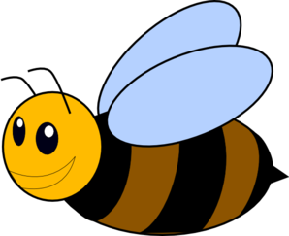

Bee Template:

