In-Class Field Trip:
Cell Toy

Estimated Time: Four 50-minute periods
GSE Standard and Element(s):
S7L2. Obtain, evaluate, and communicate information to describe how cell structures, cells, tissues, organs, and organ systems interact to maintain the basic needs of organisms.
a. Develop a model and construct an explanation of how cell structures (specifically the nucleus, cytoplasm, cell membrane, cell wall, chloroplasts, lysosome, and mitochondria) contribute to the function of the cell as a system in obtaining nutrients in order to grow, reproduce, make needed materials, and process waste. (Clarification statement: The intent is for students to demonstrate how the component structures of the cell interact and work together to allow the cell as a whole to carry out various processes. Additional structures, beyond those listed, will be addressed in high school Biology.)

Science and Engineering Practices:  Engaging in Argument from Evidence  Use an oral and written argument supported by evidence to support or refute an explanation or a model for a phenomenon. | Disciplinary Core Idea:  Structure and Function  In multicellular organisms, the body is a system of multiple interacting subsystems. These subsystems are groups of cells that work together to form tissues and organs that are specialized for particular body functions.
Crosscutting Concepts:

Systems and System Models
Systems may interact with other systems; they may have sub-systems and be a part of larger complex systems.

Authentic Scenario (Phenomena):  Show students examples of cell size and scales (slide 3 on presentation): https://learn.genetics.utah.edu/content/cells/scale/ | Vocabulary:  - plant cell  - animal cell  - structures  - processes  - functions  - nucleus  - cell wall  - cell membrane  - cytoplasm  - chloroplast  - lysosome  - mitochondria
Guiding Questions:

How are cell structure and cell function related?
Why is each part of the cell essential to survival?
Demonstrate how cell organelles work together to:
- obtain nutrients in order to grow.
- Reproduce.
- make needed materials.
- process waste.

Materials Needed:  - Device for Internet research  - Microscope  - Microscope slides  - Plant cell slides  - Animal cell slides  Student Handouts:  - CER Template  - Close Read  - STEM Challenge: Cell Toy Overview  - STEM Challenge Cell Toy Box Chart  - Eukaryotic Cell Organelle Chart  - ToyCo, Inc. Cell Toy Proposal  - Cell Toy Project Rubric | Safety Considerations:  - Students need to have Internet safety awareness when researching organelle functions.
Technology Integration:

- Device with Internet access
- Microscope with slides

Links:
https://learn.genetics.utah.edu/content/cells/scale/

Literacy Connections:

- Henrietta Lacks “Immortal” Cells (Article by The Smithsonian Institution Adapted by Newsela)

5E Stage | Student Activities  How will students engage actively in the three dimensions throughout the lesson?  Teacher Activities  How will the teacher facilitate and monitor student learning?
Engage | Remind students what a cell is and show students examples of cell size and scale (slide 3 in the presentation): https://learn.genetics.utah.edu/content/cells/scale/.  Discuss that cells can be different sizes and shapes.  Next, have students read Henrietta Lacks “Immortal” Cells. Ask students how they think the cells from Ms. Lacks can reproduce and be immortal.
Explore | Directions:  - Put students in groups of four.  - Provide students with the STEM Challenge: Cell Toy Overview and read through it with students:  ToyCo, Inc., an international supplier of gizmos, gadgets, and toys for all ages, is in need of a new product. Scientists observe and learn from the world around them. They study naturally formed structures, and then mimic these working systems to improve our daily lives. ToyCo, Inc. has contracted you as an innovative developer to study the components of a cell and design a new product that will entice a specific age group. As a team, analyze the parts that make up a cell, as well as the structure and function of each one of these parts. Then, utilize the engineering design process to generate a toy concept using the same principles that allow a cell to work through form and/or function.  - What will be the purpose of your toy?  - How will it work?  - How will you build it?  - What parts will you use and how will those parts compare to those of a cell?  - Provide students with the STEM Challenge: Cell Toy Box Chart. Students will, individually, complete the box chart, listing the facts they know and any questions they need answered before building their cell model.  - Ask groups to share questions with the class and write these on the board. Add any essential questions needed that students did not identify.  - Share the mini-lesson presentation covering the plant and animal cell processes and organelle functions with discussion questions included. Students will answer the questions throughout the presentation in their journals.  - Provide students with the Eukaryotic Cells Organelle Chart. Using the Eukaryotic Cells Organelles Chart, students will sketch a picture of a plant and animal cell, label the parts and note the function of each organelle with the label, and color.  - Refer to the Explain section for the microscope lab.  - Pass out the Cell Toy Model rubric and remind students of the presentation requirements.  - Provide students time to work on the Cell Toy Challenge and ask students to develop a toy “analogy” to model the parts of the cell. As part of the Toy Model Presentation, students will write an explanation of how cell structure is related to cell function. Give students the option of creating a Stop Motion Animation Video demonstrating their Toy Model and explaining how cell structure is related to cell function.
Explain | Directions:  - Set up the microscope lab for students to compare plant and animal cells under the microscope:  - Option 1: Provide both prepared plant and animal cell slides.  - Option 2: Provide plant cell prepared slides and display cheek cell images from a microscope on your presentation screen.  - Option 3: Provide pond water and prepare wet mount slides to observe living cells and display both pond plant and animal single-celled organisms from the presentation screen.  - Ask students to sketch what they see. Label all the visible organelles (They should see a nucleus, cell wall (plant), cytoplasm, etc.).
Elaborate | Students can explore the STEM Career: Medical Doctor by reading the GYSTC Spotlight on Dr. Dana Neacsu at this link on the GYSTC website. Click on the Be a Medical Doctor lesson to practice the skills of a medical doctor.
Evaluate | - Students can create a Stop Motion Animation Video demonstrating their Toy Model and explaining how cell structure is related to cell function.  - Post Test

CER Strategy
Claim – Evidence - Reasoning

Guiding Question:

How are cell processes related to cell structures?

Claim: (What’s your answer?)

Evidence: (Data using numbers or descriptions.)

Reasoning: (Statement that connects your data [evidence] to your answer [claim].)

Henrietta Lacks’ “Immortal” Cells
By The Smithsonian Institution, adapted by Newsela staff
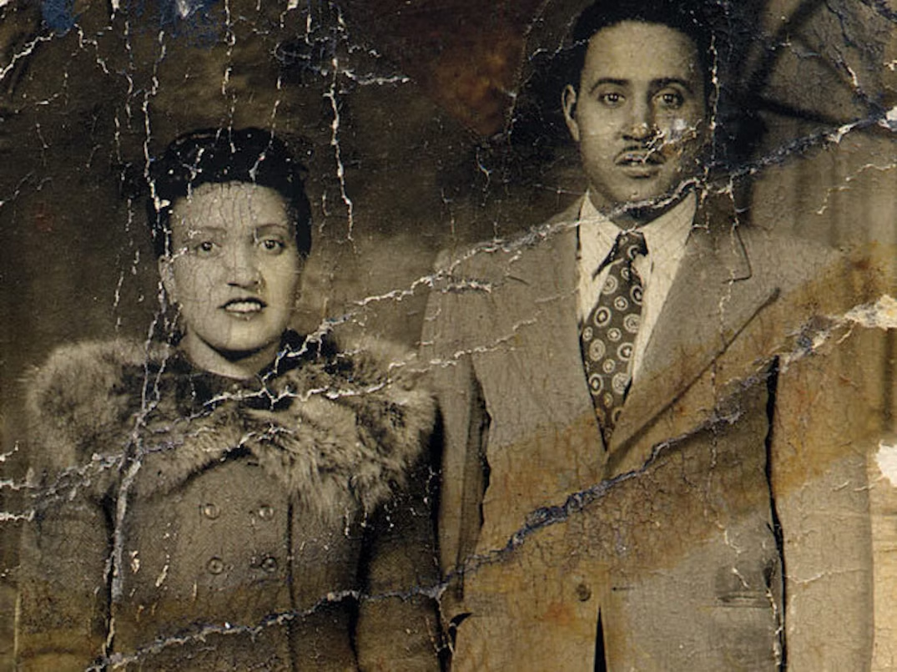

HeLa Cells (noun): An immortal cell line, the first of its kind, derived from a sample of cervical cancer taken from Henrietta Lacks in 1951.

Cervical Cancer (noun): A type of cancer that affects the cells of the cervix (the lower part of the uterus).

Cell Culture (noun): The process by which cells are grown outside their natural environment in a laboratory or other controlled setting.

Contamination Problem (noun): A situation in which something is contaminated with an unwanted substance or element.

We know no one lives forever. But, one woman's cells from 65 years ago seem to be the first immortal cells that scientists have. It was a mystery until not too long ago where these cells came from.

Cells are the building blocks of life. They are the basic unit of living things.

Scientists grow human cells in labs to learn more about the causes and treatment of diseases. They need cells that can grow forever and also stay frozen for many years.

Called HeLa Cells
In 1951, a scientist at Johns Hopkins Hospital in Baltimore, Maryland, created the first everlasting human cell line. The cells came from a young Black woman with cervical cancer.

Those cells, called HeLa cells, have been important to the world of medicine. But, no one knew much about the person they came from. When the cells were taken, they were given the code name HeLa, for the first two letters in Henrietta and Lacks. But, Henrietta's real name wasn't known until the 1970s.

Rebecca Skloot wrote a book published in 2010. It is called "The Immortal Life of Henrietta Lacks." Skloot tracked down the story behind the amazing HeLa cells.

Henrietta Lacks' Important Cells
Henrietta was a Black tobacco farmer from southern Virginia who had cancer when she was 30. A doctor in Maryland took a piece of her tumor without telling her and sent it to scientists. No one knows why, but her cells never died.

Henrietta's cells were the first human cells ever grown in culture to continue living. Grown in culture means cells are taken from where they are living, like a human body. Then the cells go to a lab so scientists can grow more of them to study.

Henrietta's cells were important to developing the polio vaccine. Polio was a deadly disease in the 20th century. Her cells also went on the first space missions to see what would happen to cells in zero gravity. Many scientists have used her cells for different types of advanced study.

Learning Henrietta's Story
Before writing her book, Skloot first learned about Henrietta in 1988. Skloot was 16 and in a science class. The teacher knew Henrietta's real name and that she was Black. But that's all he knew. When Skloot was in college, she decided to find Henrietta's family and write about them.

It took Skloot almost a year even to convince Henrietta's daughter, Deborah, to talk to her. Skloot went where Henrietta was raised in Virginia. Skloot tracked down Henrietta's cousins, then called Deborah and told her their stories.

This convinced Deborah to help Skloot learn more about Henrietta because Deborah wanted to know more, too. Deborah never knew her mother. She was a baby when Henrietta died and no one ever talked about Henrietta.

Finding Out HeLa Is Henrietta Lacks
Twenty-five years after Henrietta died, a scientist discovered that many cells thought to be from other people were in fact HeLa cells. It turned out that HeLa cells could float on dust in the air and travel on unwashed hands into other cell cultures.

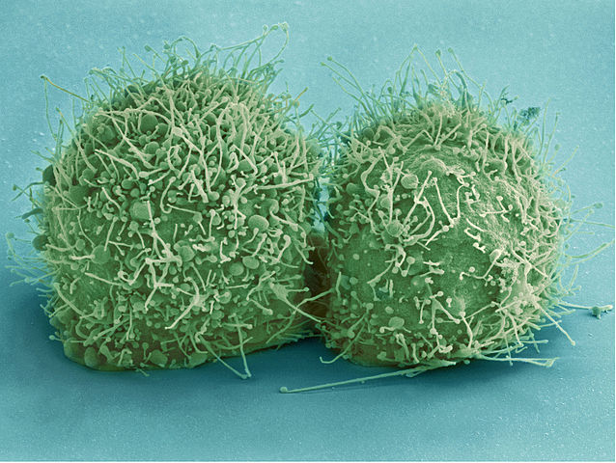
So, scientists tracked down Henrietta's relatives to take some samples from them. They wanted to use the family's DNA to make a map of Henrietta's genes. This would allow scientists to know which cells were HeLa and which weren't. It would begin to straighten out the contamination problem.

Lessons From The Book
Much of science today revolves around using human cells of some kind. The people behind those samples are usually left out of the decision-making process.

Skloot hopes people don't think collecting and growing cells is bad. Medicine today depends on it. We would not have many tests, medicines and vaccines if it wasn't for this. Or, if it wasn't for Henrietta.

STEM Challenge: Cell Toy Overview

ToyCo, Inc, an international supplier of gizmos, gadgets, and toys for all ages, is in need of a new product. Scientists observe and learn from the world around them. They study naturally formed structures, and then mimic these working systems to improve our daily lives. ToyCo, Inc. has contracted you as an innovative developer to study the components of a cell and design a new product that will entice a specific age group.

Directions:
- As a team, analyze the parts that make up a cell, as well as the structure and function of each one of these parts. Then, utilize the engineering design process to generate a toy concept using the same principles that allow a cell to work through form and/or function.
  - What will be the purpose of your toy?
  - How will it work?
  - How will you build it?
  - What parts will you use and how will those parts compare to those of a cell?
- ToyCo, Inc. would like to see at least eight of the most vital cellular components represented within the toy either structurally and/or functionally. Design and build a prototype of your toy. It must be mathematically scaled to size if not presented as actual size.
- Finally, create a written proposal and marketing presentation for the board members of ToyCo, Inc. Make sure your presentation is clearly labeled/written, attractive, colorful, well-designed, and scientifically informative. Don’t forget to include a bibliography of your sources.
  - Why should ToyCo, Inc. choose your design?
  - What will you name your product?
  - What makes your toy innovative and unique as well as interesting to the end consumer?
  - What age group will your toy target?
  - How much will it cost the consumer and how much do you predict the company will profit from the sale of each individual unit after construction?

STEM Challenge: Cell Toy Overview

Facts that I know about cells or models | Questions that I need answered before I can build my cell model

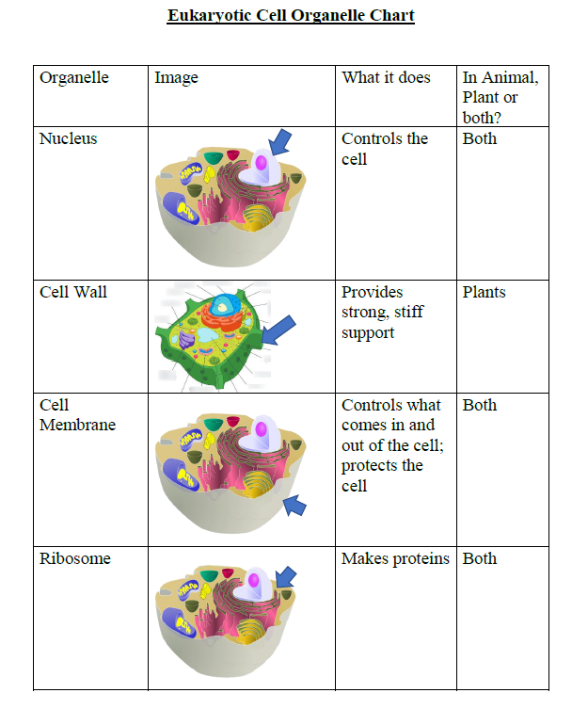

Eukaryotic Cell Organelle Chart
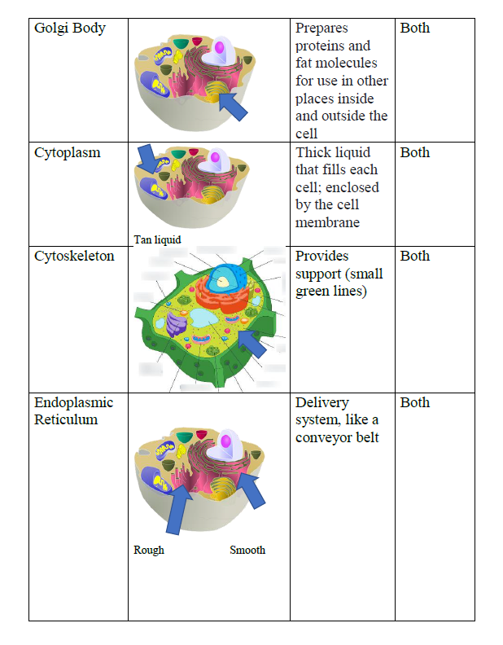

Eukaryotic Cell Organelle Chart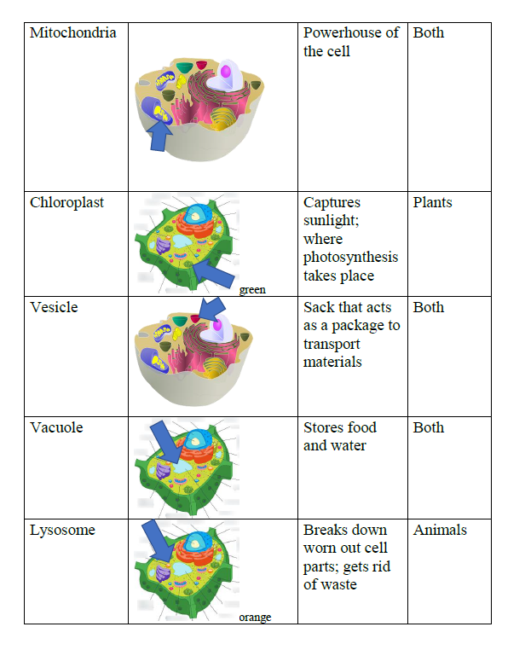

ToyCo, Inc. Cell Toy Proposal

Cell Toy Name:

Team Members:

1. Briefly describe the issue or problem that motivates this project idea proposal.

2. Describe the function or purpose of your idea/product and how it works. (Attach a labeled sketch which was used to support and develop your idea.)

3. How does your idea exhibit or model the components of a cell?

4. What are the novel features of your idea and why should ToyCo, Inc. choose your product?

5. Describe your target audience.

6. How much did it cost to build your idea?

7. What is your suggested retail price and the rationale behind your SRP?

8. What percent profit will ToyCo, Inc. acquire from selling your idea?

9. Are there any limitations that must be overcome prior to distribution?

Cells Toy Project Rubric
Team Members:
Performance | Points | Assessment
Proposal
Describes motivation behind idea, purpose, and functionality. | 5
The idea is unique and/or out-of-the-box thinking was demonstrated. | 5
A sketch of the design is neatly drawn and labeled with analogous parts of the cell identified. | 10
Describes target audience, cost of build per unit, suggested retail price, and profit margin per unit. | 5
Addresses any limitations of the idea as well as the potential for additional ideas. | 5
Presentation
Conducts an effective marketing presentation to introduce the new product. The presentation includes:  - a hook or attention grabber,  - an introduction of the problem,  - a body of content summarizing the findings which included an advertising pitch or slogan,  - and a closing statement signaling the presentation was complete. | 10
Everyone in the group communicated equally in the presentation of the material. The presentation was understandable and easy to follow. Appropriate voice volume, eye contact, and enthusiasm were present. | 5
Presentation is 5 minutes (1 point deduction for each minute less than five or over five.) | 5
Content
Addressed how at least eight parts of the functioning unit compare structurally and/or functionally to the parts of a cell. All components are accurately compared. | 40
All information is accurate and relevant. | 5
Effective and relevant use of materials were used in the design. The idea was functional at the time of the presentation. Solution/Model works to perform a task or serves as a working toy. | 5
Total | 100

