**Bee #1**

Image Source: UCSB-IZC00033148

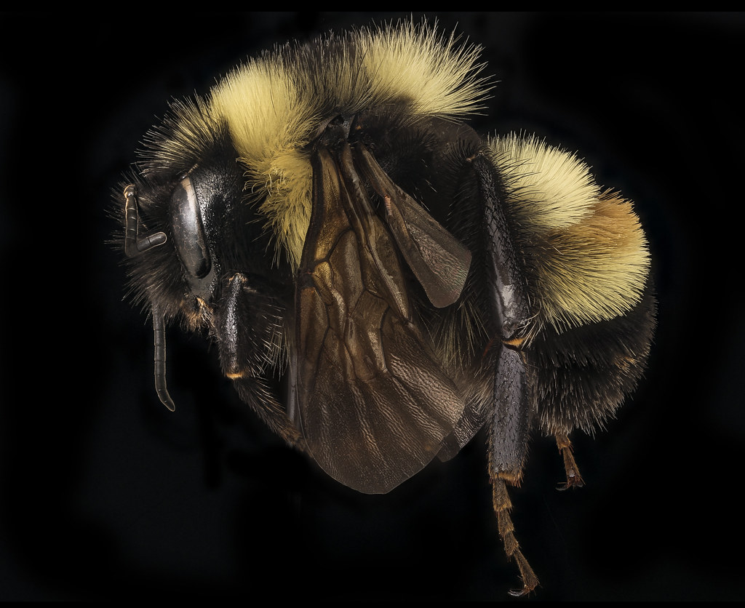

**Bee #2**

Image Source: UCSB-IZC00012184

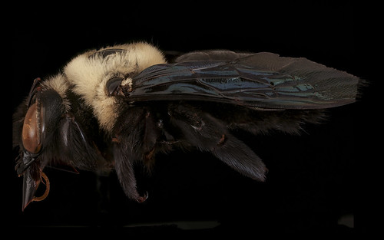

**Bee #3**

Image Source: UCSB-IZC00012184

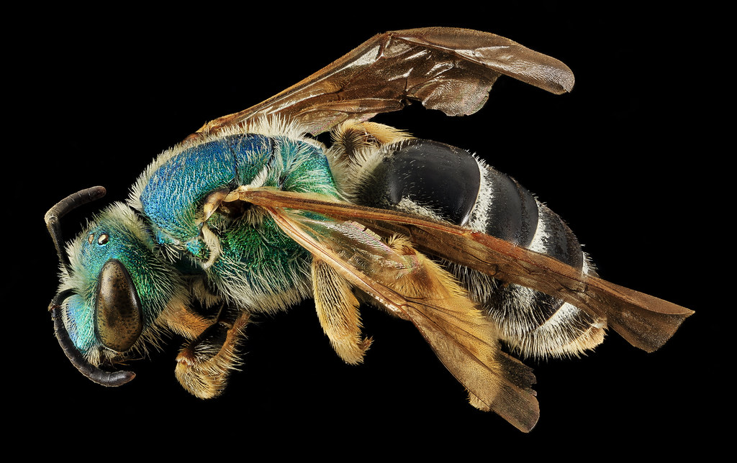

**Bee #4**

Image Source: UCSB-IZC00009350

**Bee #5**

Image Source: UCSB-IZC00012184

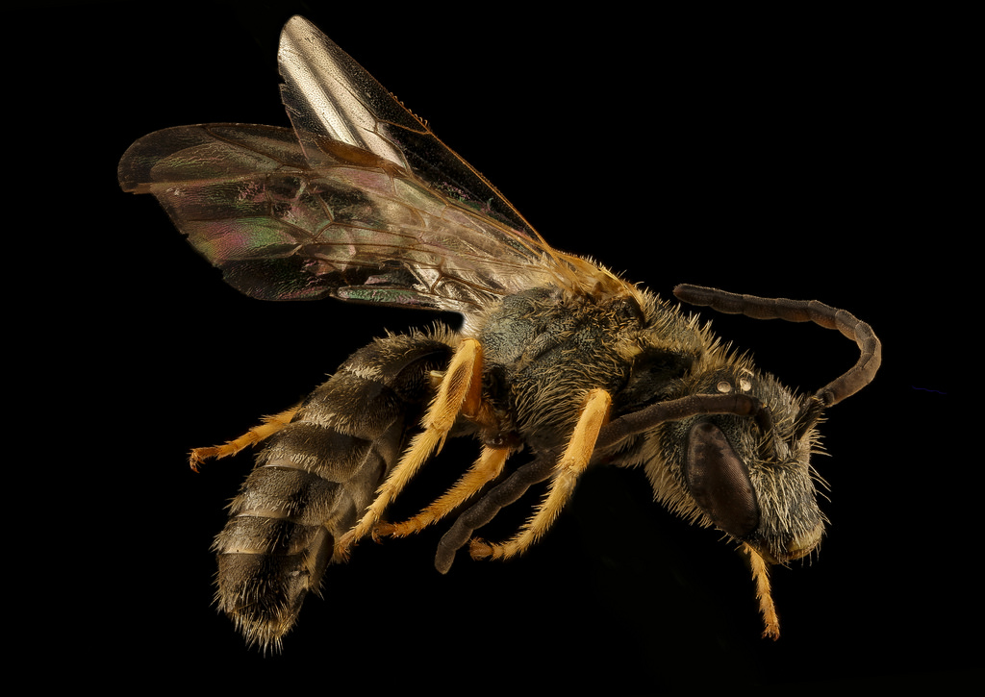

**Bee #6**

Image Source: UCSB-IZC00035588

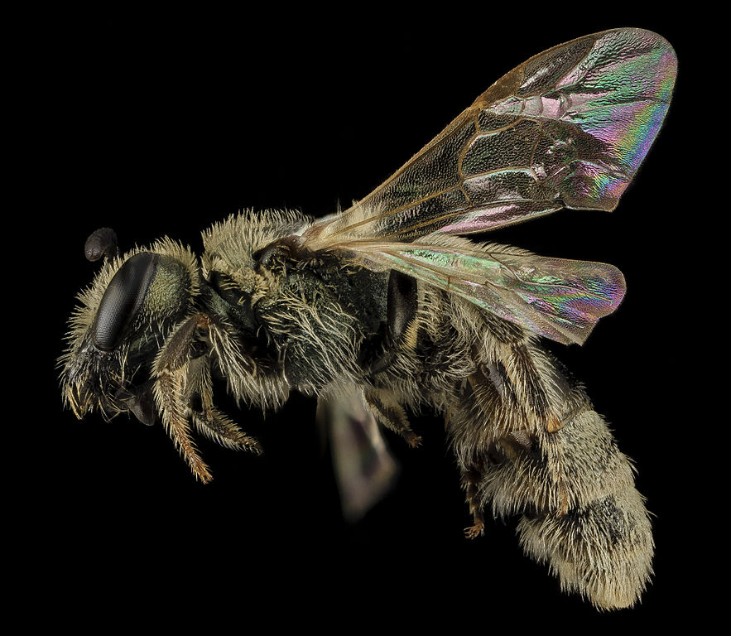

**Bee #7**

Image Source: UCSB-IZC00035468

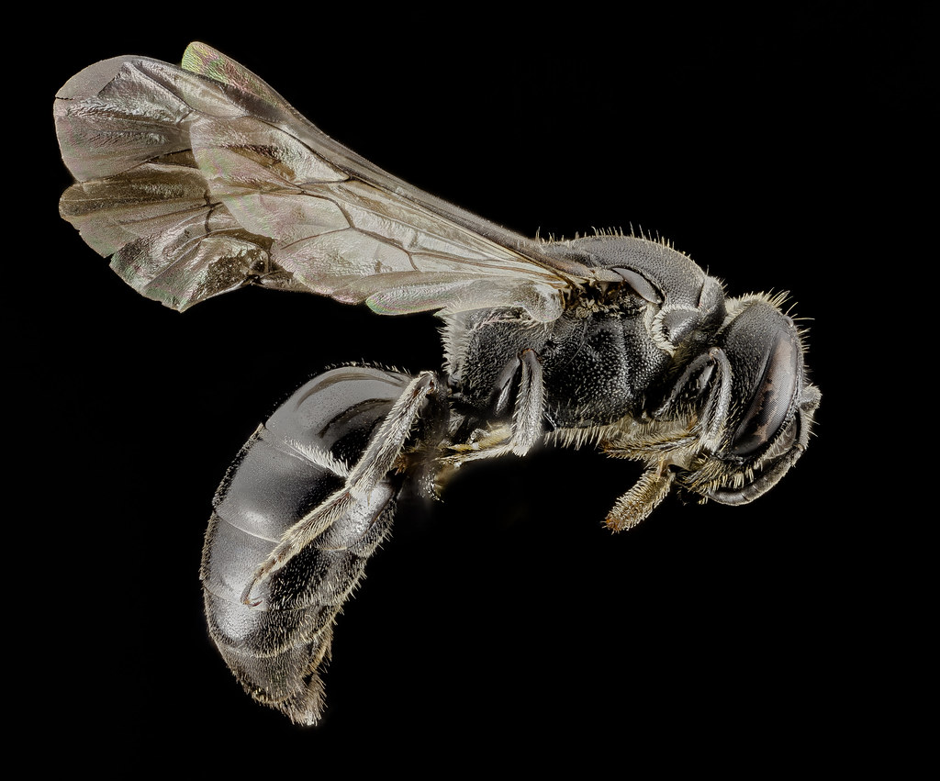

**Bee #8**

Image Source: UCSB-IZC0008718

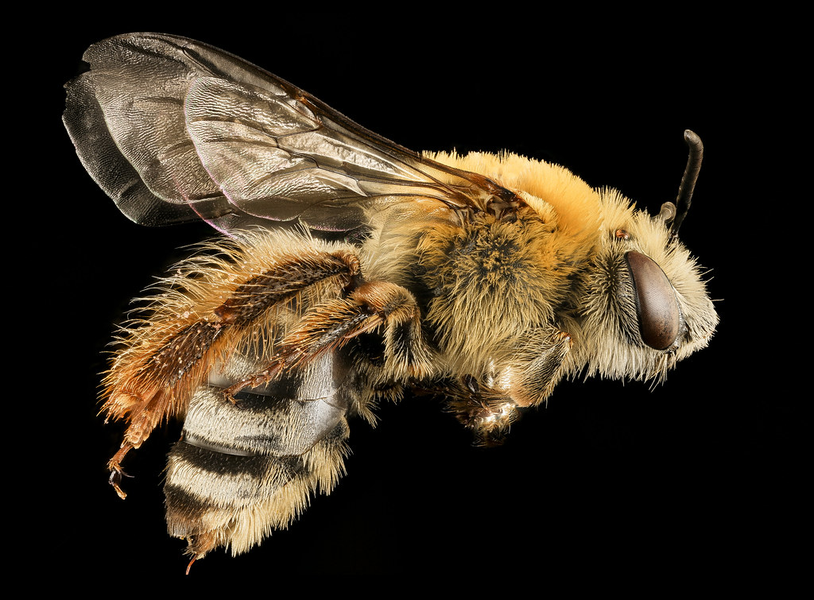

**Bee #9**

Image Source: UCSB-IZC00034398

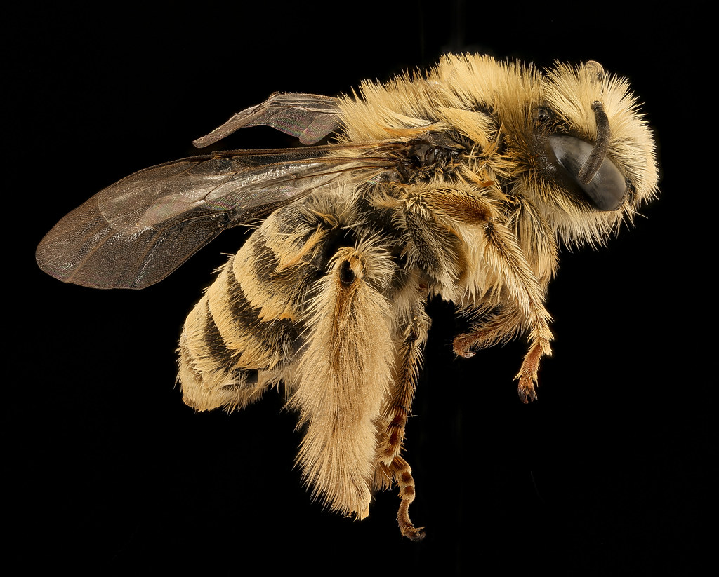

**Bee #10**

Image Source: UCSB-IZC00034457



