Gravity Railroad Pre/Post Test

1. The diagram shows two groups of students, pulling equally on a rope. What kind of force is being applied to the rope?
a. an unbalanced force
b. a balanced force
c. a drag force
d. an unequal force

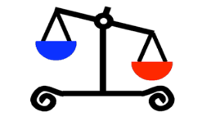
2. The diagram shows an image of a scale. What kind of force is acting on this scale?
a. an unbalanced force
b. a balanced force
c. a drag force
d. an equal force

3. What causes an object to fall to the ground when you let it drop from your hand?
a. air resistance
b. gravity
c. magnetism
d. the push from your hand

4. Which statement is correct?
a. A force does not make things change direction.
b. When you hit a baseball with your bat, you are using a balanced force.
c. A force is a push or pull.
d. A force is always strong.

5. Have you ever considered becoming a Systems Management Analyst when you grow up?
a. Yes
b. No

Gravity Railroad Pre/Post Test Answer Key
- b.
- a.
- b.
- c.

