In-Class Field Trip:
Pollution Solution

Estimated Time: 1 hour
GSE Standard and element(s):

S3L2. Obtain, evaluate, and communicate information about the effects of pollution (air, land, and water) and humans on the environment.
a. Ask questions to collect information and create records of sources and effects of pollution on the plants and animals.
b. Explore, research, and communicate solutions, such as conservation of resources and recycling of materials, to protect plants and animals.

Supporting Standards:
3.MDR.5.1 Ask questions and answer them based on gathered information, observations, and appropriate graphical displays to solve problems relevant to everyday life.

ELAGSE3RL1 Ask and answer questions to demonstrate understanding of a text, referring explicitly to the text as the basis for the answers.

ELAGSE3SL4 Report on a topic or text, tell a story, or recount an experience with appropriate facts and relevant, descriptive details, speaking clearly at an understandable pace.

Science and Engineering Practices:  Developing and Using Models  Develop and/or use a model to generate data to test ideas about phenomena in natural or designed systems, including those representing inputs and outputs, and those at unobservable scales.  Engaging in Argument from Evidence  Make a claim about the merit of a solution to a problem by citing relevant evidence about how it meets the criteria and constraints of the problem. | Disciplinary Core Idea:  Engineering, Technology, and the Application of Science: Developing Possible Solutions
Crosscutting Concepts:

Systems and System Models
A system can be described in terms of its components and their interactions.

Authentic Scenario (Phenomena):  The Great Pacific Garbage Patch is a collection of marine debris in the North Pacific Ocean. Marine debris is litter that ends up in the ocean, seas, and other large bodies of water: https://education.nationalgeographic.org/resource/great-pacific-garbage-patch | Vocabulary:  - pollution  - land  - water  - environment  - sources  - effects  - plants  - animals  - conservation  - recycling  - protect  - solution
Guiding Questions:

How can engineers help with problems caused by pollution?

Materials Needed:  - Recycled materials (paper tubes, cardboard, wooden pieces, etc.)  - Duct Tape  - Scissors  - Paper  - Pencil | Safety Considerations:  - N/A
Technology Integration:

- Students can use these sites to gather data on plastic/ocean pollution:
- https://theoceancleanup.com/
- https://ourworldindata.org/plastic-pollution

Literacy Connections:

- Ducks Overboard by Markus Motum

5E Stage | Student Activities  How will students engage actively in the three dimensions throughout the lesson?  Teacher Activities  How will the teacher facilitate and monitor student learning?
Engage | Show the students this picture:  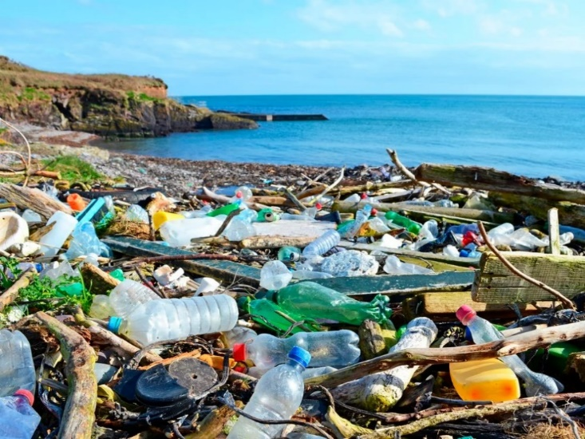  Source: https://www.smithsonianmag.com/smart-news/the-great-pacific-garbage-patch-hosts-life-in-the-open-ocean-180979168/  Ask students what they notice and wonder.  Share the video clip based on the Ocean Cleanup Project:  https://www.youtube.com/watch?v=7XZ4rCj1JN4  Stop at 1:38 so that the solution will not be shown at this point in the lesson.  Ask students for their observations and thoughts from the video.  Read the book Ducks Overboard by Markus Motum and discuss.
Explore | Have students visit https://ourworldindata.org/plastic-pollution or another similar site and gather data on plastic/ocean pollution around the world.
Explain | Every year, millions of tons of plastic enter the oceans, primarily from rivers. And the plastic that is afloat within the oceans isn’t going away by itself.  Pollution is a change in the environment that can affect the health, survival, or activities of a living thing. Water, air, and land pollution affect all the plants and animals in that area either directly or indirectly. People can make everyday choices that directly help or harm the environment. Conservation and recycling can reduce the negative effects of pollution.
Elaborate | STEM Challenge: Using recycled materials, design and build a solution to the ocean pollution that you have been learning about. Students should work in groups of 2-3.  - Ask: Are there any questions?  - Imagine: Brainstorm ideas that you have with your group.  - Plan: Draw a plan out on paper.  - Create: Build your design and test it out.  - Improve: Do you need to make any changes to your creation?  Have groups share their creation and explain how it will work.  Share information about the ocean cleanup project as inspiration from https://theoceancleanup.com/about/. Dutch inventor Boyan Slat founded The Ocean Cleanup at the age of 18 in his hometown of Delft, the Netherlands.  https://www.youtube.com/watch?v=SczfY6ijlgE
Evaluate | Have students write a paragraph in their STEM journals about their project. They must include information about ocean pollution, why they built their creation, and explain how it will work.

