In-Class Field Trip:
Renew-A-Bead

Estimated Time: Two 45-Minute Class Segments
GSE Standard and Element(s):
S6E6. Obtain, evaluate, and communicate information about the uses and conservation of various natural resources and how they impact the Earth.
a. Ask questions to determine the differences between renewable/sustainable energy resources (examples: hydro, solar, wind, geothermal, tidal, biomass) and nonrenewable energy resources (examples: nuclear: uranium, fossil fuels: oil, coal, and natural gas), and how they are used in our everyday lives.
b. Design and evaluate solutions for sustaining the quality and supply of natural resources such as water, soil, and air.
c. Construct an argument evaluating contributions to the rise in global temperatures over the past century. (Clarification statement: Tables, graphs, and maps of global and regional temperatures, and atmospheric levels of greenhouse gases such as carbon dioxide and methane, should be used as sources of evidence.)

Science and Engineering Practices:  Asking Questions and Defining Problems  Constructing Explanations and Designing Solutions  Engaging in Argument from Evidence  Obtaining, Evaluating, and Communicating Information | Disciplinary Core Idea:  ESS3.A: Natural Resources  ESS3.D: Global Climate Change
Crosscutting Concepts:

Patterns
Cause and Effect
Systems and System Models
Authentic Scenario (Phenomena):  Photovoltaics (often shortened as PV) is the process of converting light (photons) into electricity (voltage), which is called the photovoltaic effect. This type of solar cell is being used to power space satellites and smaller items such as calculators and watches. | Vocabulary:  - conservation  - renewable resources  - nonrenewable resources  - energy sources  - photovoltaic
Guiding Questions:

What are the different sources of energy?
How could an increased dependence on renewable energy sources impact our future?
How is the depletion of fossil fuels a serious global issue?
Graphically represent data and explain the trends.
How do scientists use models of a real-life phenomenon to aid in understanding and researching?
How might the conservation and resource strategies used today affect your future?
In what sense is the energy from wind, hydroelectric, coal, and oil really energy from the sun?

Materials Needed:  - black and white beads  - paper bags  - plastic bags  - cloth or plate (to count beads on)  - calculators  - Energy Sources and Conversion Graphic Organizer  - Renew-A-Bead Game Handout  For Elaborate:  - Energy Resources Research Handout | Safety Considerations:  - N/A
Technology Integration:

- A calculator
- A device with Internet access
Literacy Connections:

- A Refreshing Look at Renewable Energy with Max Axiom, Super Scientist by Katherine E. Krohn

5E Stage | Student Activities  How will students engage actively in the three dimensions throughout the lesson?  Teacher Activities  How will the teacher facilitate and monitor student learning?
Engage | Begin the class with a brainstorming discussion. Students are already familiar with some of these issues:  - Where does the energy we use come from? Energy comes from an energy source. (Write the heading “Sources” on the board and brainstorm with the class for examples of energy sources.)  - What do we know about these energy sources? (Show pictures provided in the lesson PowerPoint). Each of these sources has a starting form and is converted into a different form for our convenient use. (Hand out the Energy Sources and Conversion Graphic Organizer for students to use to take notes).  - Fossil Fuels – chemical (petroleum, natural gas, coal)  - Uranium – nuclear  - Biomass – chemical  - Geothermal – heat (generated from nuclear processes within the Earth)  - Hydro – mechanical  - Wind – mechanical  - Solar - electromagnetic  Can we use this energy in its form? For example, can sunlight be directly used to power a radio? No, a solar photovoltaic panel must be used for energy conversion. An energy system is a set of conversion technologies that convert energy resources, such as energy from the sun, into forms that we can utilize for human needs.  Energy resources that are replenished at the same rate that we use them are defined as renewable energy resources. Solar, wind, geothermal, and tidal energy are examples of renewable energy. Biomass can be renewable if we use the plant material at the same rate that it regrows. But, if we chop down and burn all the trees in a short period of time, that resource is not considered renewable.  Fossil fuels are also a form of solar energy because they were generated from biomass materials millions of years ago. They are not renewable because we are using them at a much faster rate than they are being regenerated.
Explore | Renew-A-Bead Game:  The goal of today’s game is to use a model of an energy system to see how important renewable resources are so that our country (represented by the paper bag) does not run out of energy (represented by the beads).  Before class:  - Count out the colored beads and put them into paper bags for each group (see directions below).  - Organize the rest of the materials for each group.  - Make copies of the Renew-a-Bead Game Handout, one per student.  Each group needs:  - 1 paper bag containing 100 black and white beads, with black beads representing non-renewable energy resources and white beads representing renewable energy resources; the ratio of black to white beads should vary by group:  - 95 black beads + 5 white beads  - 90 black beads + 10 white beads  - 80 black beads + 20 white beads  - 70 black beads + 30 white beads  - A small cloth  - An extra bag  - A calculator  - Renew-A-Bead Game Handout, one per student  With the students:  - Divide the class into partners. Distribute the materials.  - Provide context and kick off the game by presenting the Engage content.  - Make sure students understand that the bag and beads are intended to represent a country and its energy resources mix; we call this a model.  - Expect students to be able to follow the worksheet instructions and complete the tasks.
Explain | As a class, regroup and compare answers among the different "countries." Discuss results and takeaways. Suggested questions and topics to cover:  - What happened to the black beads? (The non-renewable energy units were all used up! Relate this to the importance of a country obtaining some renewable energy resources, given that present fossil fuel reserves will inevitably be used up at some point in the future.)  - Looking ahead, what advice would you give to a country that is making plans so it has enough future energy resources? (Many possible answers. One possible solution to our current energy situation is to use more renewable resources now, rather than mostly non-renewable energy resources. If fossil fuels are limited, what is our smartest use of them?)  - What is a model? What was the model in today's game? What do the game components represent? (The Renew-A-Bead game is an example of modeling. Scientists and engineers often make models to help them understand situations, discover issues and problems, and find alternatives, improvements, and solutions. Talk about how modeling is used in your research and/or classes.)
Elaborate | Energy Sources Research:  Although most of the energy consumed in the United States comes from fossil fuel sources, there are many other potential sources of energy available. In all cases, there are pros and cons to our use of these sources. Some of the energy sources are limited by their availability or environmental impact; others need technological improvements before they can become widely used. For scientists and engineers, research is the best way to learn about unknown topics.  Today you will examine information about energy sources and how those sources are used to produce electrical energy. We can use this information to help us understand the various pros and cons that affect our use of different energy sources.  In this activity, each group of students will begin to become an expert on one aspect of each source of energy and report their findings back to the class.  - Break into groups of three students.  - Students can choose or the teacher can assign one particular research question about each source of energy (the seven research questions are on the Energy Resources Research Handout).  - Find the answer to your question for all seven energy sources.  - If additional information is required and you have access to the internet, try:  - http://www.howstuffworks.com/  - http://howthingswork.virginia.edu/  - http://www.how-things-work-science-projects.com/  - http://www.eia.doe.gov/kids/energyfacts/index.html  - Once you have answered your question for all seven sources, answer the two conclusion questions. As a class, we will fill in the energy sources chart based on your findings.
Evaluate | - At the end of the activity, students should hand in their data tables and answers to the discussion questions for teacher review.  - Post-Test

Energy Sources and Conversions Graphic Organizer

Name: _____________________________________ Date: ___________________

Fill in blanks as discussed in class.

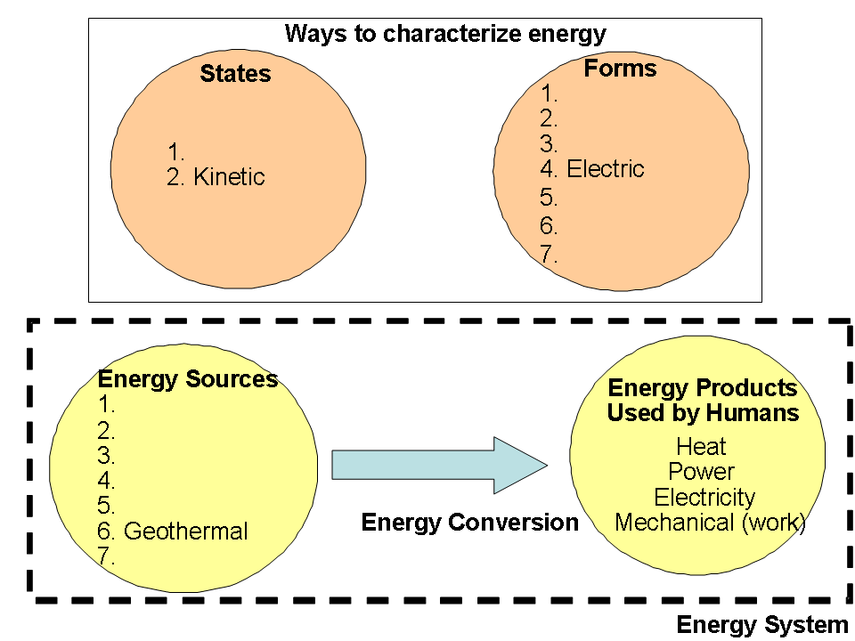

Renew-A-Bead Game Handout

Name: __________________________________ Date: _____________________

Purpose:
The sources that provide the energy we use every day can be divided into two different groups: Renewable and Non-Renewable. Renewable energy sources are those that are continuously replenished in a reasonable time frame. Non-renewable energy sources are those that are used and cannot be recreated in a short period of time.

In this activity, you will be given a bag of “energy beads.” Each bag contains energy provided by both renewable (white beads) and non-renewable (black beads) sources. You will “use” the energy provided by both types of sources by randomly picking beads from a bag – some of the “energy” you use will be renewable, and some will be non-renewable. You will see what happens to the renewable/non-renewable energy sources that remain after many years of energy use.

Materials:
  - One paper bag containing 100 beads. The black beads represent non-renewable energy resources, and the white beads represent renewable energy resources (the ratio of white beads to black beads will vary depending on your group).
  - A small cloth or paper plate
  - An extra bag
  - A calculator
  - A pencil

Procedure:
    - Split into partners.
    - Collect all equipment and materials necessary to conduct the activity.

Part 1: Simulate the annual consumption of energy - constant rate of energy use.
    - Have one person from each group pick out 10 “energy beads” from the bag, without looking. These 10 beads represent the energy that is used in one year.
    - Count the black and white beads and record the number on the attached data collection sheet for Year 1.
    - The black beads represent energy from non-renewable energy sources, so when a black bead is picked it cannot be returned to the bag (place it in the extra plastic bag). The white beads are renewable energy beads, so they should be put back into the bag each turn after counting them.
    - Let another person from the group pick 10 beads to represent energy use in Year 2. Fill in the number of black and white beads on the chart and return the white beads as in step 5.
    - Repeat the process, returning all the white beads to the bag after each person’s turn, until 20 years have passed or until all the black energy beads are gone.

Part 2: Simulate the annual consumption of energy - increasing rate of energy use.
    - The world population is increasing by about 75 million people per year. Consider the increasing use of power and energy over time as the world’s population grows. Repeat steps 3 through 7 but increase the amount of energy use by picking out 5 additional “energy beads” each year (pick 10 beads in year 1, 15 beads in year 2, 20 beads in year 3, etc.). Record information on the attached data collection sheet.
    - Complete the discussion questions.

Discussion Questions:
- How many years did it take for the non-renewable energy sources to run out when you used 10 energy beads per year? How many years did it take for the non-renewable energy sources to run out when you increased the rate of consumption each year (Part 2)? What conclusion can you draw from this about our energy use habits if the population continues to grow?

- What are some examples of renewable and non-renewable energy sources?

- What does this activity demonstrate about our consumption of resources - what will happen if we keep using non-renewable resources?

- Describe what happens to the proportion of renewable vs. non-renewable energy sources that remain available, as energy is used over time.

- Compare the results with other groups with different energy mixes. If each bag represents a country, what can you say about countries that currently use a greater fraction of renewable energy? Will they be able to continue to provide for their country’s energy needs?
6. Look at Figure 1, below, and answer the questions that follow:

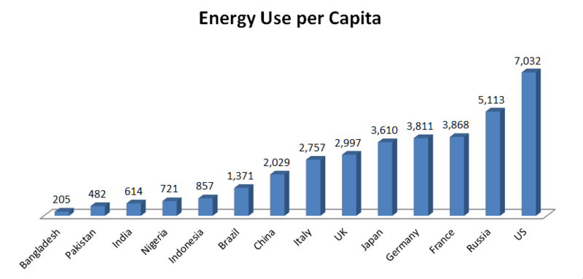
Figure 1. 2011 Energy use per person for different countries in units of Kg of oil equivalent. Source: World Bank via Wikimedia Commons (http://en.wikipedia.org/wiki/File:Energy_Use_per_Capita.png)

a. How many times more energy does a person living in the U.S. use each year compared to a person living in India?

b. Why do you think there are such differences between countries?

c. If the world population increases (as it is expected to) but we could choose how much energy each person uses, which country should we choose as a model to prolong our energy resources?
Renew-A-Bead Data Collection
Part 1: 10 energy beads used each year
Year | Total beads removed | Number black beads | Number white beads | Percent of beads that are renewable | Number of beads remaining
1 | 10
2 | 10
3 | 10
4 | 10
5 | 10
6 | 10
7 | 10
8 | 10
9 | 10
10 | 10
11 | 10
12 | 10
13 | 10
14 | 10
15 | 10
16 | 10
17 | 10
18 | 10
19 | 10
20 | 10

Renew-A-Bead Data Collection
Part 2: Increasing use of energy each year by 5 beads
Year | Total beads removed | Number black beads | Number white beads | Percent of beads that are renewable | Number of beads remaining
1 | 10
2 | 15
3 | 20
4 | 25
5 | 30
6 | 35
7 | 40
8 | 45
9 | 50
10 | 55
11 | 60
12 | 65
13 | 70
14 | 75
15 | 80
16 | 85
17 | 90
18 | 95
19 | 100
20

Energy Resources Research Handout

Name: _________________________________ Date: _____________________

Purpose:
Although most of the energy consumed in the United States comes from fossil fuel sources, there are many other potential sources of energy available. In all cases, there are pros and cons to our use of these sources. Some of the energy sources are limited by their availability or environmental impact; others need technological improvements before they can become widely used. For scientists and engineers, research is the best way to learn about unknown topics. Today we will examine information about energy sources and how those sources are used to produce electrical energy. We can use this information to help us understand the various pros and cons that affect our use of different energy sources. In this activity, each group of students will begin to become an expert on one aspect of each source of energy and report their findings back to the class.

Procedure:
- Break into groups of three students.
- Students can choose or the teacher can assign one particular research question about each source of energy (see below).
- Find the answer to your question for all seven energy sources.
- If additional information is required and you have access to the internet, try:
    - http://www.howstuffworks.com/
    - http://howthingswork.virginia.edu/
    - http://www.how-things-work-science-projects.com/
    - http://www.eia.doe.gov/kids/energyfacts/index.html
- Once you have answered your question for all seven sources, answer the two conclusion questions.
- As a class we will fill in the energy sources chart based on your findings.

Research Questions:
  - What is this energy source? Where can we find it?
  - How do we harness the energy? (How does it work?)
  - Are there different types or uses of this source? If yes, what are the differences?
  - What are the environmental impacts of your energy source?
  - What are the economic impacts of your energy source? How much does it cost per kWh?
  - What countries currently use this source? What percentage is used in the United States?
  - How is this energy source currently used? For example: At farms, in industry, etc. Could this source be used in a family home?
Research Answers
Your Research Question (1-7):

- Biomass

- Fossil Fuels

- Geothermal

- Hydropower

- Uranium

- Solar

- Wind

Discussion Questions
- If you had to choose an energy system to tell your community about based only on the aspect you researched, which system would you choose? Why?

- Why do we as a nation depend so much on fossil fuels? AND What do you think we could do to reduce this dependence on fossil fuels?

While listening to the other groups in your class present their information, list some “pros” and “cons” of using their energy source to solve your problem.
Energy Source | “pros” | “cons”
Biomass
Fossil Fuels
Geothermal
Hydropower
Uranium
Solar
Wind

