STEM Career:
Engineer

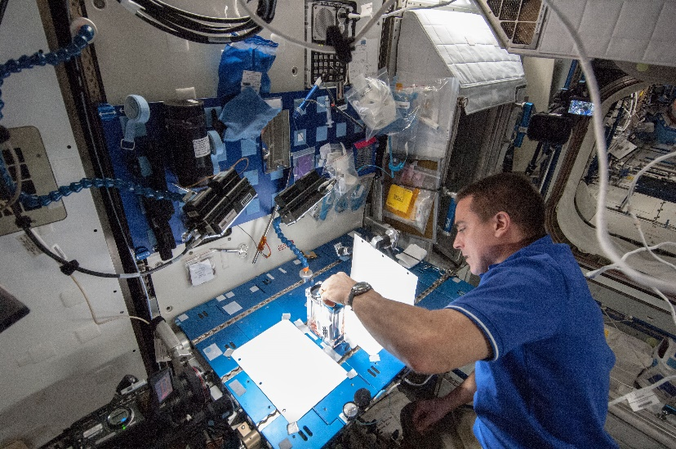
An engineer is a person who designs and builds complex products, machines, systems, or structures. Engineers want to know how and why things work. They have scientific training that they use to make practical things. Engineers often specialize in a specific branch of engineering. The field of engineering is divided into branches such as civil, electrical, mechanical, and chemical engineering.

Engineers:
- Identify the problem or challenge.
- Identify design requirements and limitations on the design due to available resources and the environment.
- Brainstorm possible solutions to the problem or challenge.
- Generate ideas and develop the most promising ones.
- Explore possibilities and the pros and cons of each.
- Select an approach by identifying the design that appears to solve the problem best.
- Build a model or prototype.
- Refine the design by identifying changes that need to be made and improving the model or prototype.

Engineering positions typically require a bachelor’s degree in engineering or a relevant field. Some engineering jobs, especially in management, require a master's degree. An engineering degree in a specialty area may qualify engineers for a career in a related field. Whatever your area of focus, an engineering degree will require a heavy dose of math and science courses.

STEM Career Video: https://education.nationalgeographic.org/resource/build-future-intro-video/

