STEM Career:
Entomologist

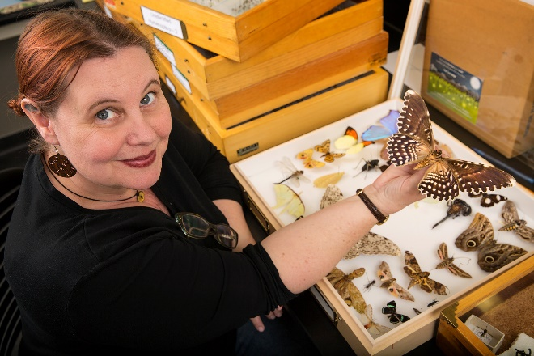
Entomologists study insects, such as ants, bees, and beetles. They also study arthropods, a related group of species that includes spiders and scorpions. Most entomologists specialize in a particular type of insect. Insects outnumber all other forms of life combined and perform functions vital to life on Earth. Consequently, entomologists make many important contributions to scientific knowledge, such as the best ways to pollinate crops, conserve insect species, and protect crops, trees, wildlife, and livestock from pests. Understanding the roles insects play in their environments can also help us restore disturbed ecosystems and clean up contaminated sites. Some entomologists study how climate change will affect insect species and their distributions.

Entomologists:
- study how to protect crops from pests, without harming beneficial insect species like bees. They may develop new types of "integrated pest management" that uses some species to control others, reducing the need for pesticides.
- research ways to prevent the spread of diseases like West Nile Virus and Rocky Mountain Spotted Fever from insects to people.
- help solve murder cases by studying the insects associated with dead bodies. They can help determine the timeline and location of a crime.

Some entry-level positions are open to candidates with bachelor's degrees in entomology or related scientific fields, such as biology. Entomology programs usually cover insect biology and physiology, pest management, insect-borne diseases, insect taxonomy and morphology, and veterinary entomology.

Advanced degrees may be necessary for advancement. Doctoral degrees are generally required for faculty positions at colleges and universities. The Entomological Society of America offers optional certification programs. The Associate Certified Entomologist (ACE) credential is for structural entomologists, and the Board Certified Entomologist (BCE) credential is for entomologists in general.

STEM Career Video: https://www.youtube.com/watch?v=NzmB2sljgcg

