STEM Career:
Magnetic Resonance Imaging (MRI) Technician

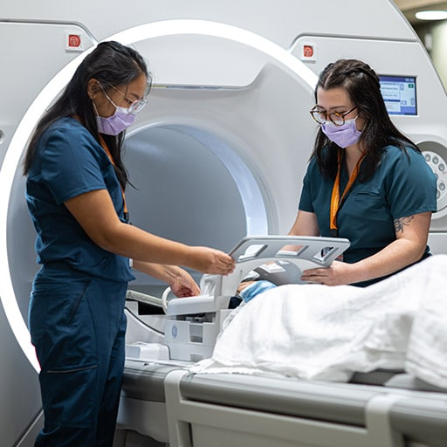
Electromagnets are used in magnetic resonance imaging (MRI) machines to create a magnetic field around a patient and look inside a patient’s body. Magnetic forces send radio waves throughout a patient’s body and create pictures of the tissues. MRI technicians are responsible for preparing and executing an MRI procedure. Not only do they explain the procedure to the patient, but they also help move the patient onto the MRI platform. Once the MRI procedure is complete, technicians develop the images and pass them on to physicians.

MRI Technicians:
- Take images of internal organs and tissues.
- Interpret a physician’s instructions.
- Explain MRI procedures to patients.
- Select software options and imaging parameters.
- Maneuver heavy examination equipment.
- Prepare patients for procedures.
- Move disabled patients from wheelchairs onto examination tables.
- View images from an imaging session and keep records of the results.

Education:
MRI technicians need a bachelor’s degree.

Earnings:
According to salary.com, as of 2010, MRI technicians earn an average annual salary of $65,000.

STEM Career Video: https://www.youtube.com/watch?v=NGOUxvxQksU

