STEM Career:
Medical Doctor

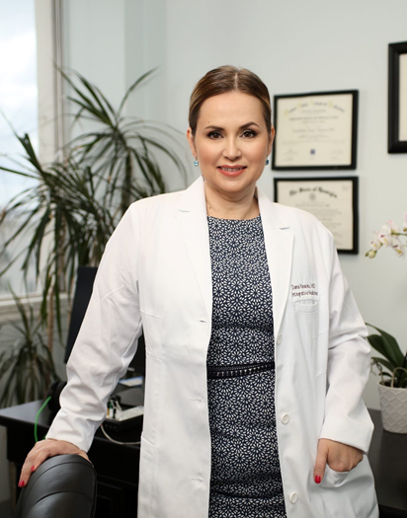
Medical doctors work to ease physical and mental suffering due to injury and disease. They diagnose medical conditions and then prescribe or administer appropriate treatments. Medical doctors also seek to prevent medical problems in their patients by advising preventative care. Ultimately, medical doctors try to help people live and feel better at every age.

Medical Doctors:
- Detect heart disease before it becomes fatal.
- Surgically repair and monitor the healing of a broken bone.
- Provide medical care to people in impoverished countries.

Formal education and training requirements for medical doctors are among the most demanding of any occupation—4 years of undergraduate school, 4 years of medical school, and 3-8 years of internship and residency, depending on the specialty selected. A few medical schools offer combined undergraduate and medical school programs that last 6 years, rather than the customary 8 years.

Premedical students must complete undergraduate work in physics, biology, mathematics, English, and inorganic and organic chemistry. Students also take courses in the humanities and the social sciences. Some students volunteer at local hospitals or clinics to gain practical experience in the health professions.

STEM Career Video: https://youtu.be/46UArj0_qE4

