STEM Career:
Wastewater Treatment Engineer

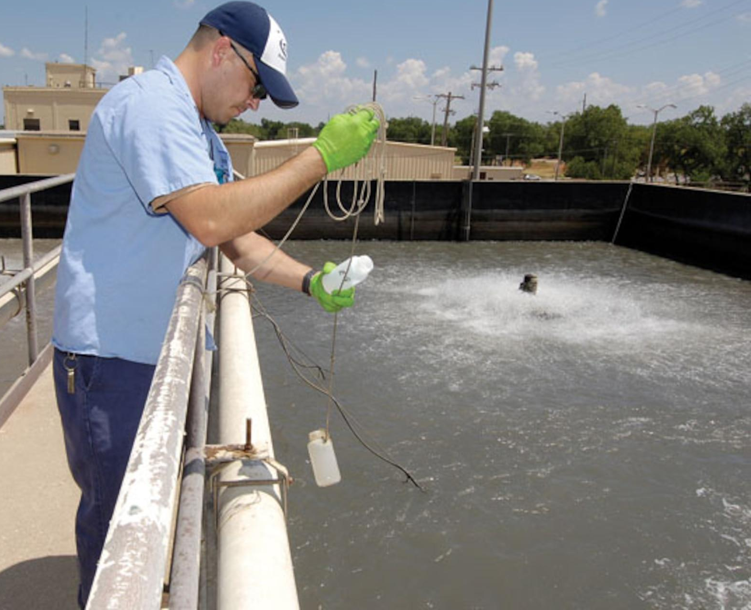
Wastewater treatment engineers play a crucial role in safeguarding our environment and public health. They are responsible for designing, implementing, and managing systems that treat and dispose of wastewater, ensuring it meets regulatory standards before returning to the environment. Wastewater treatment engineers work in various settings, including municipal water treatment plants, industrial facilities, and consulting firms.

Duties include but are not limited to:
- Designing Treatment Systems: Wastewater treatment engineers create systems that remove pollutants and contaminants from wastewater, making it safe for discharge or reuse.
- Environmental Impact Assessment: They assess the environmental impact of wastewater treatment processes, ensuring compliance with environmental regulations.
- Project Management: Engineers manage projects, including budgeting, scheduling, and overseeing construction and maintenance activities.
- Research and Development: They stay updated with emerging technologies and conduct research to improve wastewater treatment methods, making them more efficient and sustainable.
- Collaboration: Wastewater treatment engineers collaborate with multidisciplinary teams, including scientists, regulators, and technicians, to achieve effective wastewater treatment solutions.
Education:
Wastewater treatment engineers typically hold a bachelor's degree in environmental engineering, civil engineering, or a related field. Some positions may require a master's degree for advanced research or management roles. Continuous professional development and certifications are essential to stay current with evolving technologies and regulations.
Earnings:
According to the Bureau of Labor Statistics, as of 2022, the median annual wage for environmental engineers, including wastewater treatment engineers, was $96,530. Salaries vary based on experience, education, location, and the specific industry.
STEM Career Video: https://youtu.be/JSxcetMCZZ0
Wastewater treatment engineers play a vital role in ensuring the responsible management of wastewater, protecting natural resources, and promoting a sustainable future.

